*Topic 11.1 A New Wave of Immigration*Name __________________________

## 

**I. Immigrants from Eastern and Southern Europe: Jews, Italians, Slavs: Poles, Russians, Czechs etc…**

**Push Factors (from homeland) Pull Factors (to the US)**

**II. ______________________________ helped with the crossing. Most people in the**

**_____________________ section- crowded, dirty and diseases there.**

**III. Many immigrants passed through ___________________ centers. They had check ups & answered**

**questions. A few received new names. Most were _______________________ laborers.**

**They settled where they found ________: mines, mills, & factories - living mainly in cities.**

**_______________ population swelled Boston, NY, Philadelphia, Chicago, etc…**

**IV. Padrones found jobs, shelter, & food for immigrants in return for _________________ or a vote.**

**V. _____________________________ main processing center for Europeans on the east coast.**

**_____________________________ main processing center for Asian immigrants on the west coast.**

**VI. Immigrants often moved near people from their own __________________: same language, religion,**

**traditions, and culture. __________________________- blended cultures (old with new- holidays)**

**A. Younger immigrants were more eager then older immigrants to adopt new ___________________**

**ways. Many boys joined gangs.**

**B. Schools were doubling in _______________________________. Schools taught social behavior,**

**citizenship, skills, & vocational courses.**

**VII. ______________________________ wanted to limit immigration.**

**VIII. _____________________ Exclusion Act of 1882: no Chinese could enter the US for 10 years then**

**renewed several times. American Protective Association wanted to eliminate all immigration.**

*11.2 Urbanization*

**I. People moved to cities for _____________: steel mills, meat packing, garment factories, clerks, waiters, barbers, bank tellers, & secretaries**

**II. African Americans moved to _________________________ cities from the south.**

**III. Cities ________________!! Garbage was everywhere, no sewers, horse manure, pollution, etc..**

**People lived in ______________________- no windows, heat, in door bathrooms or 1 per floor.**

**Disease was rampant. High _________________ rate and dangerous areas were in cities.**

**IV. Reforms Needed: building codes, _______________ laws, street lights, police, fire, & sewer systems.**

**V. Help for the cities: Social Gospel, Salvation Army, YMHA, YWHA, YWCA.**

**Jane _______________________________: Hull House to help poor immigrants in Chicago.**

*11.3 The Rise of Progressivism*

**I. 1880’s-1920’s era called ____________________ because of wealthy extravagance.**

**II. Cities were corrupt. Political bosses won elections then gave out contract for roads, sewers, garbage, etc… The “bosses” received ______________ or payoffs from the chosen company. To ensure the “bosses” were elected they had people help the poor or immigrants: find jobs, give**

**food or coal when needed or in return for a _____________.**

**III. NYC- Boss Tweed, mayor, cheated his city out of $100 million. People**

**figured it out when Thomas _______ published political cartoons about Tweed’s _____________.**

**IV. Spoils system: __________________- elected officials give jobs to their supporters.**

**V. Civil Service Commission conducts exams for federal jobs. People receive jobs based**

**on ___________________.**

**VI. Sherman Anti Trust Act helped break up _______________ & monopolies.**

**VII. Muckrakers wrote about corruption & societies problems. Upton Sinclair wrote**

***The ________________* about meatpacking _________________.**

**VIII. _____________________________ wanted to change societies problems for the good**

**IX. Political reforms: __________________ Idea- primary elections, initiative, referendum, & recall.**

**A. 16th Amendment: income _________**

**B. 17th Amendment: direct election of ________________**

*11.4 The Progressive Presidents*

**I. McKinley was __________________________ in 1901. TR (Teddy Roosevelt) became president.**

**II. TR: _________________________- lawsuits against Standard Oil & American Tobacco. He also**

**supported labor unions & meat packing laws after reading The Jungle.**

**III. The public like ______________ digging up the dirt or problems. In 1906 Congress passed**

**the Pure Food & Drug Act & Meat Inspection Act.**

**IV. TR was a _______________________________ and set aside land for national parks.**

**For the 1908 election TR backed William Taft. The public didn’t like Taft.**

**V. In 1912 Republicans nominate Taft, Democrats nominate Woodrow ____________, and TR runs**

**for the Bull Moose party. Taft and TR split the republican vote, so Democrat ___________ won.**

**VI. Federal Reserve Act regulated banking.**

**VII. Federal Trade Commission investigates companies persuades them to stop**

**using unfair trade practices.**

*11.5 Progress and Setbacks for Social Justice*

**I. National Woman Suffrage Association- worked to get women’s right to vote.**

**A. Women were able to _____________________ in west before east.**

**B. 19th Amendment: Women’s Suffrage**

**II. Florence Kelly: wanted to improve conditions in ______________________________.**

**A. Carrie ______________: prohibition- stormed into saloons and tore them up with a hatchet.**

**B. 18th Amendment; banned making, selling, transporting _____________________.**

**III. Jim Crow laws in the south –__________________ of public places - lynchings in the South.**

**IV. Booker T. __________________- founded Tuskegee Institute in Alabama**

**V. W.E.B. DuBois, Jane Addams, Lincoln Steffens organized the __________________:**

**National Association for the Advancement of Colored People.**

**VI. G. W. Carver- experimented with peanuts, Madame C.J. __________________ created hair products**

**VII. Mexican Immigrants left Mexico because of war & famine. They acculturated and lived in**

**___________________________ in big cities.**

**VIII. Chinese Population declined because of Chinese _________________________ Act.**

**IX. Many Japanese moved to the US. In CA. ________________ students were segregated Gentlemen’s Agreement- stop Japanese immigration to US and the wives can join the husband’s already here.**

**X. Native Americans- ___________________ of American Indians to help Native Americans.**

*11.6 A Changing American Culture*

**I. Cities were growing, ______________________________ were necessary: elevators needed.**

**II. Some moved to ___________________________ for health reasons. Inventions: ice box,**

**Lawnmowers, ranges, washing machines, electric trolley’s etc…**

**III. _______________________ were built in cities because lack of greenery: Central Park**

**(cities were ugly.) The St. Louis and _________________________ Bridges were built.**

**IV. ________________________ became popular in the late 1800’s- newspapers, department stores,**

**sports, bicycling, _______________________________, & nickelodeons**

**V. People saw __________________________________ in papers, so window shopping became**

**popular at department stores. _____________________ names became important.**

**VI. Baseball (Cincinnati Red Stockings), Football, & Basketball - James Naismith invented- popular.**

**VII. People went to see a variety of vaudeville acts like ___________________ Brothers or**

**short films called __________________________________.**

**VIII. ____________________ music became popular- Scott Joplin. Marching Bands- John Phillip Sousa.**

**IX. By 1900 most Northern cities had compulsory education.**

**A. Required kids through________ grade to attend school. School was from 8-4 teaching**

**reading, writing, arithmetic, civics, & English.**

**B. Parochial schools & colleges/universities were built.**

**X. Joseph _________________________ published World newspaper & added extras- comics**

**fashion, crime etc…- William Randolph ______________________ competed with**

**his new Journal newspaper. They sensationalized headlines using**

**__________________________________ so people would buy their paper.**

**XI. Dime novels & magazines were published for the new readers.**

**XII. Realist authors tried to show harsh reality. Mark __________ (Samuel Clemons) became famous.**

**XIII. Artists also painted realistic scenes- from Civil War Battles to _____________________in the south.**

Presidents

[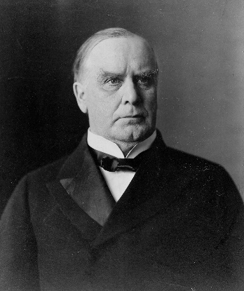](https://www.google.com/url?sa=i&rct=j&q=&esrc=s&source=images&cd=&cad=rja&uact=8&ved=0ahUKEwjfqMTapfTOAhUnzIMKHQ-FAEcQjRwIBw&url=https://en.wikipedia.org/wiki/William_McKinley&bvm=bv.131783435,d.amc&psig=AFQjCNHCU7vchZtuiVkDgs4vFjjiiW57uQ&ust=1473029784091163)[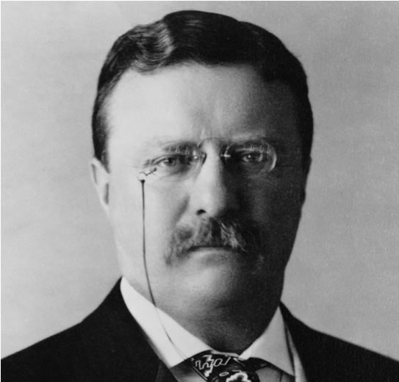](http://www.google.com/url?sa=i&rct=j&q=&esrc=s&source=images&cd=&cad=rja&uact=8&ved=0ahUKEwjLpre7pfTOAhWl34MKHSxoAPYQjRwIBw&url=http://mrnussbaum.com/presidents/theodore_roosevelt/&psig=AFQjCNHob7PsjZj1rHx2nRB_RBhL-BHDoA&ust=1473029704142461)[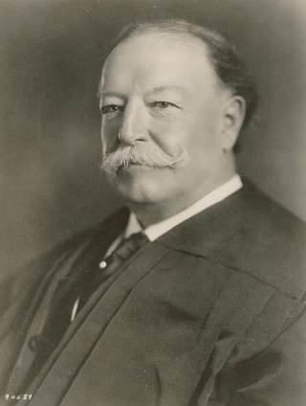](https://www.google.com/url?sa=i&rct=j&q=&esrc=s&source=images&cd=&cad=rja&uact=8&ved=0ahUKEwjgjubzpfTOAhVm7IMKHd43CD4QjRwIBw&url=https://en.wikipedia.org/wiki/William_Howard_Taft&bvm=bv.131783435,d.amc&psig=AFQjCNETkJv1kuN--dUgsvGFc5fTakZQcg&ust=1473029835876125)[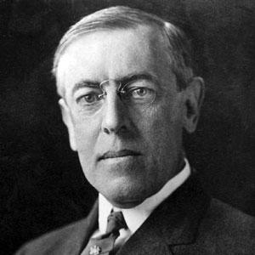](http://www.google.com/url?sa=i&rct=j&q=&esrc=s&source=images&cd=&cad=rja&uact=8&ved=0ahUKEwix8daVpvTOAhWlxYMKHZeABvYQjRwIBw&url=http://billpomerenk.com/travel/presidents/Woodrow_Wilson/Woodrow_Wilson.html&bvm=bv.131783435,d.amc&psig=AFQjCNETLLYMOk1Ju21fmSu2hu0TJtvJCw&ust=1473029876565652)

**William McKinley Teddy Roosevelt William Taft Woodrow Wilson**

**ANGEL ISLAND ELLIS ISLAND**

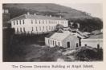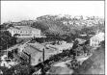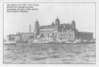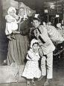

**CITY LIFE**

[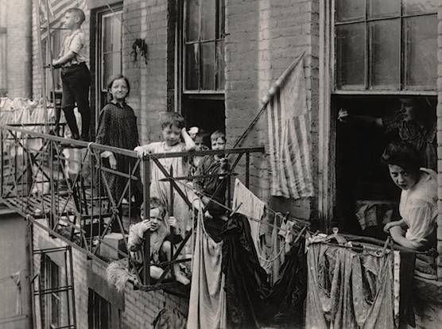](https://www.google.com/url?sa=i&rct=j&q=&esrc=s&source=images&cd=&cad=rja&uact=8&ved=0ahUKEwj9mtnwqvTOAhVJ7IMKHaqIAbIQjRwIBw&url=https://www.pinterest.com/pin/449867450249012424/&bvm=bv.131783435,d.amc&psig=AFQjCNElim978h_lTrCDKAjsJeDoM4B9Zg&ust=1473031156184158) [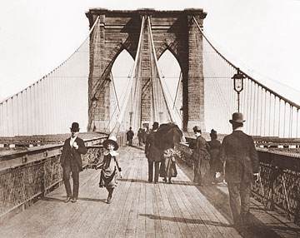](http://www.google.com/url?sa=i&rct=j&q=&esrc=s&source=images&cd=&cad=rja&uact=8&ved=0ahUKEwjDq4Cbq_TOAhWly4MKHRnYCPQQjRwIBw&url=http://www.photosofoldamerica.com/index.cfm/New_York_City_Bridges-The_Brooklyn_Bridge_Pedestrian_Walkway_208.htm&bvm=bv.131783435,d.amc&psig=AFQjCNHTh-FNYzxfznzoEAS9tBwfDs0bGQ&ust=1473031252427282)

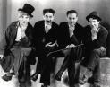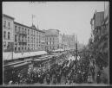

[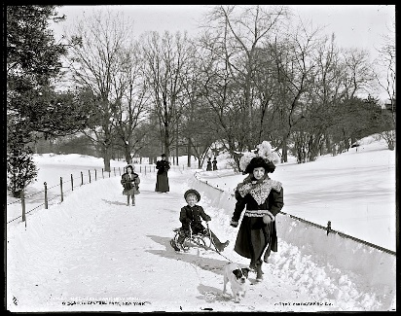](http://www.google.com/url?sa=i&rct=j&q=&esrc=s&source=images&cd=&cad=rja&uact=8&ved=0ahUKEwi24-2zq_TOAhUH_IMKHQYJCkcQjRwIBw&url=http://www.nycstylelittlecannoli.com/2016/01/throwback-thursday-central-park-snow.html&bvm=bv.131783435,d.amc&psig=AFQjCNFEJZREXK5I4bMtzLaf2M0CtIb_XQ&ust=1473031295099012)[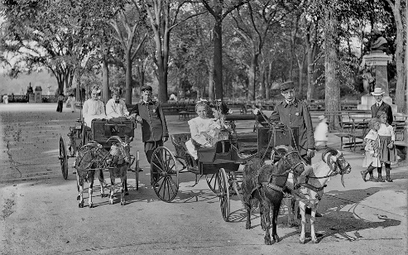](https://www.google.com/url?sa=i&rct=j&q=&esrc=s&source=images&cd=&cad=rja&uact=8&ved=0ahUKEwjm-_7Uq_TOAhUB4oMKHRNABy8QjRwIBw&url=https://www.flickr.com/photos/are-oh-why/8474251833&bvm=bv.131783435,d.amc&psig=AFQjCNFEJZREXK5I4bMtzLaf2M0CtIb_XQ&ust=1473031295099012)[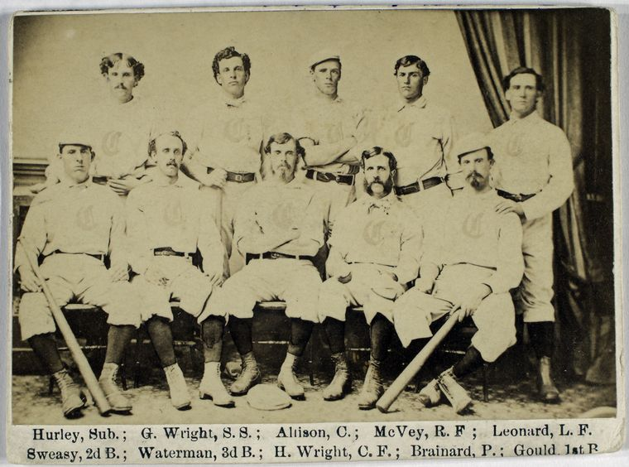](https://www.google.com/url?sa=i&rct=j&q=&esrc=s&source=images&cd=&cad=rja&uact=8&ved=0ahUKEwi72riOrPTOAhXo34MKHUlvCHcQjRwIBw&url=https://en.wikipedia.org/wiki/Cincinnati_Red_Stockings&bvm=bv.131783435,d.amc&psig=AFQjCNGb8VRLo-f7qLj5VK39RY-ZQf2lFA&ust=1473031494131855)