U.S. 1820 Map 32 points Name __________________________
Date ________________ hour ______
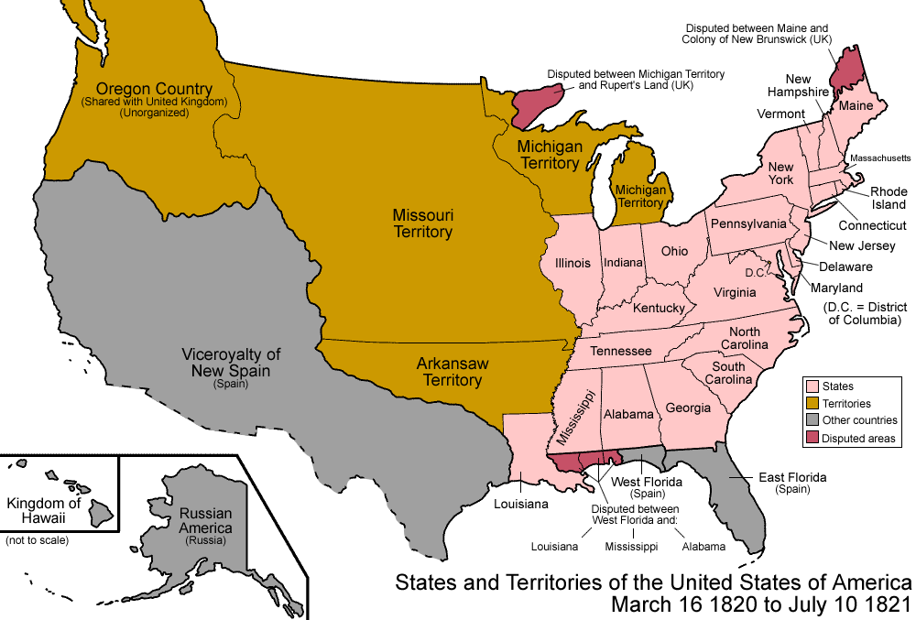

Label the 23 states, 6 Territories, Rocky Mts., and Atlantic and Pacific Oceans = 32 points Use pp. 309, 325, 1042

