Name ______________________
Topic 6: The Age of Jackson and the Westward Expansion
6.1: Jackson wins the Presidency

I. U.S. democracy was growing throughout the country and into the west.
A. more states added to the country
B. In the West, any white man over 21 could vote- voter turnout was high in the early 1800’s.
C. No voting for women, Native Americans, and most African Americans
II. Election of 1824- John Quincy Adams is chosen by the House of Reps. because no majority
-Andrew Jackson lost but grew up poor, war hero, and admired- political rivalries
A. Adams promoted economic growth- internal improvements- roads, canals, etc…
B. Whig Party- most were old Republicans- strong federal government, pay for internal
improvements, high tariffs, federal banking system- relied on manufacturing & commerce
C. If the US imposes tariffs, other countries will put tariffs on the US- hurt US exports
D. Democratic Party- Andrew Jackson-opposed tariffs, federal government taking a big role in economics, more power for white men, and to open the west to settlement
III. Andrew Jackson won the 1828 election- many in South and West supported him-
for the common white man- farmers and city workers
A. Jackson nickname “Old Hickory”- tough, fighter, poor growing up, from the West,
became lawyer and wealthy buying land- huge crowds at his inauguration
B. Jacksonian Democracy- to help the common man- growth of political parties and citizen
participation in the political process
C. Spoils system- Jackson fired many government employees and hired his supporters

6.2 Political Conflict and Economic Crisis

I. State’s Rights- North included New England and Mid-Atlantic States- favored manufacturing
and trade, West is what is now the Midwest livelihood based on small farms
South is Southeast and South Central relied on farming and cash crops for exports-
tobacco and cotton. The North and South didn’t agree and the West agreed sometimes
with the North and sometimes with the South. The South didn’t want tariffs.
II. John C. Calhoun believed states had the right to nullification- cancel a federal law- states could
reject federal laws they felt were unconstitutional. Daniel Webster and Andrew Jackson
disagreed. Vice President Calhoun resigned.
III. Congress enacted a new lower tariff. South Carolina passed the Nullification Act- declaring
the new tariff illegal. There was a compromise new lower tariff.
IV. The Democrats opposed the Second Bank of the US and Whigs supported it.
A. The National bank limited the amount of loans state banks could give.
B. Rich private bankers ran the national bank- Jackson opposed this.
C. Jackson vetoed the bank renewal in 1832 and refused to put money in the national
bank. The Second Bank of the US was eliminated and led to an economic crisis later.
V. 1936- Martin Van Buren elected president.
A. 1837- depression because the banking system- state banks giving out too
many loans, not enough money to back the loans
B. Depression lasted 5 years.
C. Widespread unemployment
VI. 1840 election- William Henry Harrison won- hero from the Battle of Tippecanoe- died
of pneumonia 32 days after taking office- Vice President John Tyler becomes president

6.3: Native Americans on the Frontier

I. Settlers often attacked Native Americans for land or in response to Native raids on whites.
Many Natives had sided with British in Rev. War and War of 1812- Natives were defeated.
Some adopted white ways hoping to end any conflict (farmed etc...)
A. The Cherokee created a legal and government system, began reading and writing,
published a newspaper
B. Indians didn’t want to sell their land to whites. 1825 and 1827 Georgia passed laws
forcing Creeks to give up most of their land. 1828 Georgia claimed they could make
laws for the Cherokee
C. Worcester v. Georgia- Georgia had no right to enforce laws in Cherokee Territory.
The U.S. government made legal binding treaties with Natives- so Georgia unconstitutional.
D. The Indian Removal Act 1830- Congress set aside land east of the Mississippi River
for Natives in exchange for their land in the east.
E. Northern Indians, Ottawa, Potawatomi, Sauk, and Fox signed treaties to move west.
II. Forced migration of Indians to the western land included Choctaw, Chickasaw, Cherokee,
and Seminole. Most signed treaties and agreed to move to the Indian Territory.
A. Choctaw- walked west 1831-1833- not enough blankets, tents, food, shoes, supplies etc..
B. Chickasaw- government agreed to pay $3 million, but didn’t for 30 years- many died
on the way to the reservation
C. Cherokee- Trail of Tears- US Army forced more than 15,000 Cherokee to move
in the winter of 1838-1839- thousands died along the way
D. Seminole- Chief Osceola- fought the US Army in 1817-1818, Second Seminole
War 1835-1842, Third Seminole War 1858- Seminoles defeated and forced to leave FL
E. In their new homes on “Indian Territory”, Natives struggled to rebuild their lives.
Soon settlers would set their eyes on the Indian lands in the west.
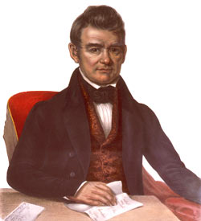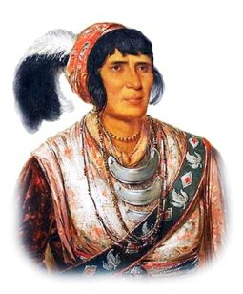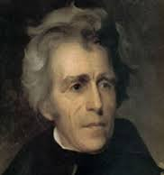
President
Andrew
Jackson-
he is on the $20 bill.
Cherokee
Chief John Ross

Seminole
Chief Osceola

