Name _________________________hr. __
Topic 7.1-7.4 - Society and Culture Before the Civil War 366-418

7.1: The Industrial Revolution and Life in the North

I. ____________________________- long, slow process- changed the way goods were produced
A. Before 1800’s most goods made by hand
B. ___________________ replaced tools & ______________ replaced human and animal power
C. British Industrial Revolution- 1700’s- wanted to keep the knowledge a secret
D. Spinning Jenny- spins several threads at one time
E. Large _______________ needed to be near rivers for waterpower.
F. Capitalists built and invested their money in new factories for _____________________.
G. Goods made by machines lowered the cost- made more product.
H. Samuel _____________ from Britain memorized how to make and operate the machines. He
emigrated to the US in 1789. He built the first successful textile mill in Pawtucket, RI.
I. Eli Whitney invented ___________________ parts to fix machinery (guns, clocks, locks etc…)
J. War of 1812 and British blockade- Americans produced more goods.
K. First factories built by water and materials needed.
L. Investors borrowed money on credit- low taxes, expanded ventures- vast amounts of wealth
M. New York __________________ Exchange started in 1792.
N. Demand high with supply low meant big profits and higher prices for goods- same for workers
II. Cities emerged where there were factories
A. Francis Cabot _______- Lowell Mills combined spinning and weaving- hired young girls called
Lowell ________- sent wages home to family- lived in boarding houses with rules to protect
the girls- hired women and children to pay them less.
B. ______________ (boys and girls) worked in factories as young as 7- small bodies and hands.
Children worked hard on the farms too.
C. 12 hour days, 6 days a week- long hard tedious work- conditions would worsen
D. Family members left the home to find work, more women worked too
III. Many left the farms for cities to find work- _______________________
A. Problems in growing cities- environment, dirt/gravel roads-mud, no sewers, garbage in
streets, pollution in waterways, contaminated water, _________________, smoke and soot
B. Attractions in cities- museums, theaters, circuses, shops- ready-made clothes etc…
IV. New inventions- advancing science and ________________
A. Cast iron stove- Philo Stewart, Electrical current- Joseph Henry, Thomas Davenport-
electric motor, Thomas Howe- sewing machine
B. New farm products- Jethro Wood- iron plow with replaceable parts, John Deere-
lightweight steel plow, Cyrus McCormick- reapers, mechanical drill, threshing machine
C. Communication improvements- Samuel Morse- ____________- gain information about goods,
prices, markets, etc…by 1850 a telegraph cable was laid between the US and Europe
V. Steam Power- steam powered railroads- faster, easier, cheaper transportation of people & goods
A. _____________- dangerous- soft roadbeds & unsafe bridges, broke down, thick black smoke,
no standard gauge (distance between rails)- transferred to different rail lines.

B. Railroad boom- across the US- increased commerce
C. Trade with other countries increased (cotton, fur, wheat, lumber, tobacco)- clipper ships- fast-
then 1850’s __________________________ even better
D. Factories and machines began using steam at a lower price.
E. Mass ______________ lowered prices and increased the US standard of living, better wages,
better diets, more newspapers and magazines, so more advertising for new products
VI. Factories in the 1840’s-1850’s different from early 1800’s – owners wanted profits & didn’t care
about the _________________________
A. Entire families labored in factories- 4:00 am to 7:30 pm- dangerous work, few windows,
no heat, no safety devices, many accidents, no __________ regulating conditions
B. Workers tried to organize, 1820’s-30’s trade ______- called for shorter workday, higher wages,
and better conditions- sometimes went on strike (illegal)- but faced jail or fines or were fired
C. Artisans- skilled workers won shorter days and better pay- unskilled workers were easy to
replace and didn’t receive any demands.
D. Rise in social class between the rich and poor.
E. ____________were paid less on a job and many unions didn’t want women- tried to organize
V. Minorities in the North
A. Northern European ______________________- British came for higher wages
B. Irish came when there was a Potato Famine in the 1840’s- starvation and disease in Ireland
C. Germans emigrated during food shortages and revolution in 1830’s-40’s, including Jewish
D. Immigrants became farmers and worked in the factories
E. ________________- native born, white citizens- anti-immigrant- said they stole jobs and
were different (Catholics, Jews, etc..)
F. ____________________________ Party- anti immigrant and anti-Catholic
G. Little slavery in the North, but African Americans were discriminated against- but many
successful African Americans in the North

7.2: King Cotton and Life in the South

I. The Cotton ____________________- South’s soil ideal for cotton to ship North and to Britain
A. Eli _________________- Cotton Gin in 1792- removed the seeds from cotton
B. By 1850- planters grew over 2 million bales a year
C. Large plantations with slave labor in the South and West- fertile soil, warm temps, rainfall
D. Other southern crops- rice, sugar cane, and tobacco and livestock- hogs, oxen, horses, cattle
E. More agriculture- relied on plantations with slave __________- but some industry in the South
F. Some big cities with same problems as the North- poor housing and sanitation
G. The South purchased ______________________ goods from the North- relied on North
II. Most whites in South were not rich planters and didn’t own slaves
A. Plantation life dominated the South- elegant clothes, acted like nobility, lavish life, became
_________________________ leaders
B. 75% of South- small farmers- owned small farmers and maybe 1-2 slaves
C. Poor whites- didn’t own slaves or the land they farmed- hard life

D. In the South the wealthiest owned slaves, in the North the wealthiest were capitalists
III. Both free and enslaved African Americans lived in the south
A. Enslaved Africans had no _____________, free African Americans faced discrimination
B. Free African Americans received their freedom in the Revolutionary War or bought their it
C. Many were farmers, laborers and ____________ (blacksmith, carpenters, cobblers), operated
businesses- many laws passed in the south making it hard for free African Americans
D. Enslaved Africans made up 30% of the South’s _________________- most slaves worked on
cotton plantations- some were servants, skilled artisans, or worked in cities
IV. Slavery in the South- strict laws and slave owners- conditions varied
A. Slave _________- laws to keep African Americans from running away or rebelling- forbidden to gather in groups more than 3, needed a written pass to leave their owners land, couldn’t
own guns, couldn’t learn to read or write, couldn’t testify in court
B. Some slaves were mistreated- but valuable property- worked 16 hour days
C. South didn’t recognize marriages or ____________- families broken apart- children or spouses
D. Some families and extended families stayed together- taught traditional African stories & songs, religion was acceptable
E. As a form of resistance- some broke tools, stole food, destroyed crops etc…
F. Many African Americans tried to _______________ to the North or turned to violence.
G. Denmark Vesey planned revolt in 1822- he and 35 others executed
H. Nat Turner led a revolt in 1831- killed whites- he was caught and hung
I. Southern whites _____________________ a revolt or uprising

7.3: Reform Movements

I. Political Reforms- against slavery and injustices against women
A. Second Great Awakening- people could save themselves by their actions
B. ___________________ revivals- meetings to promote religion
II. Social Reforms- help with prisons, disables, education, and slavery
A. Dorthea Dix- help the outsiders- the criminals and mentally ill- many women in prison actually
mentally ill- harsh conditions in prisons- built mental _________________________
B. 5 out of 6 people in jail were _________________ (poor)
C. Temperance movement against alcohol in the1820’s- devil rum could lead to abuse and
families breaking up
III. Horace ________ of Boston believed educated citizens would become better Christians- built new
schools, extended school year, raised teacher’s pay- and opened 3 colleges- other
states followed to improve schools and set up tax supported elementary schools. Schooling
ended in ______ grade in the North and South. Some schools set up for blacks in the North.
African Americans opened their own schools. 1854- Pennsylvania set up the first African
American college for men
IV. Some schools set up for people with disabilities- like for deaf or blind

7.4: Abolitionism

I. Religious beliefs led some to oppose slavery
A. ________________ felt slavery was a sin- everyone is equal in the eyes of God.
B. Ministers wanted Christians to stamp out slavery.
C. Slavery wasn’t important to the North’s economy.
D. 1787- Northwest Ordinance ______________ slavery from that territory- now Midwest.
E. One million slaves in the South- little support for ending slavery
F. A movement in the US was a new society in African for freed slaves and other Africans called Liberia. Many slaves born in the US, they didn’t want to go to Africa.
II. ______________- reformers wanting to end slavery completely in the US- almost all Northerners
A. Freedom’s Journal- abolitionist newspaper
B. Some abolitionists called for slaves to free themselves anyway they can.
C. Frederick ______________- African American abolitionist- he learned to read as a slave and
escaped in 1838- published an anti-abolitionist newspaper called the North Star.
D. William Lloyd Garrison launched The Liberator in 1831 and helped found New England AntiSlavery Society
E. Angelina and Sarah Grimke daughters of a South Carolina slaveholder- hated slavery- moved
North to speak against slavery
F. Underground __________________- a network of black and white abolitionists who secretly helped enslaved Africans escape to freedom in the North or Canada
G. Harriet ___________- an escaped slave that returned to the South 19 times to help others to
freedom- more than 300 enslaved Africans Americans- her nickname was “Black Moses”.
Slaves owners offered a $40,000 reward for capture.
H. Harriet Beecher Stowe wrote Uncle Tom’s Cabin in 1852- a novel describing the suffering
of enslaved African Americans- convinced many Northerners of the ___________ of slavery
III. By the mid 1800’s- slavery existed only in the _____________
A. Some in the North felt ending slavery would ruin their livelihood- mill owners, bankers, and merchants- they felt slavery should be left up to states- there were attacks on abolitionists
B. Southerners were for slavery even if they owned none
C. Many southerners accused abolitionists of preaching violence.
D. Southerners responded to abolitionists that slaves were better off than the northerners
workers who labored all day in factories with bad working conditions for low pay.
E. To the southerners, slavery was ______________ to the southern way of life.
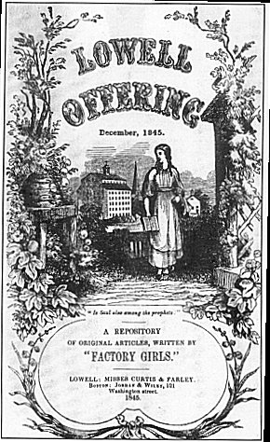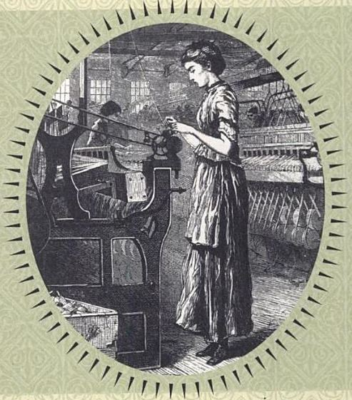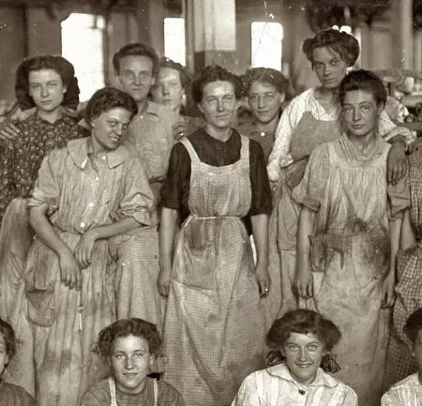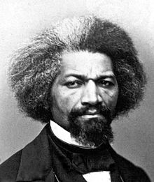
Lowell Mill flyer Lowell Mill Girl Textile Mill Workers Frederick Douglas

