Name _______________________
Topic 8: Sectionalism and Civil War (1820-1865)

8.1: Conflicts and Compromises

I. The _______________ Compromise- Missouri entered as a slave state and Maine as a free state
A. Louisiana Purchase states entering after 1820 North of Missouri would be a free state,
South a possible slave state
B. Slave and Free ____________ were still equal- so balance of power in Congress equal
II. States entering the Union that wasn’t a part of Louisiana Purchase questionable
A. Wilmot Proviso- lands gained from Mexico banned slavery- defeated in Senate
B. Abolitionists wanted slavery banned everywhere, South wanted slaves in all territories,
others wanted popular sovereignty- the people in the state to decide
C. Free Soil Party- new party to keep slavery out of the ______________
D___________________ won the 1848 Presidential election- slavery was a national issue
III. Southerners feared California and then Oregon, Utah, and New Mexico entering as free states.
A. Conflicts in Congress over slavery- John C. Calhoun wanted it in the West. Henry Clay
wanted to preserve the union
B. Henry Clay’s ________________- California enter as free state, divided the rest of Mexican Cession into territories with popular sovereignty, ended slave trade in Washington DC, included a strict fugitive slave law, settled border dispute between US and Mexico
C. __________________________ of 1850- everyone had to help catch slaves or be fined
D. Northern states enacted personal liberty laws
E. North and South not satisfied with new laws
IV. Harriet Beecher Stowe’s book _______________________________ showed the evils of slavery

8.2: Growing Tensions

I. Kansas-Nebraska Act- _____________________________- settlers in the territories decide slavery
A. __________________________ won the 1852 Presidential election- supported bill
B. Northerners not satisfied with Kansas-Nebraska Act
C. 2 rival governments in Kansas- one proslavery other opposed to slavery- violence over it
D. _______________ and abolitionist- murdered 5 proslavery men after a raid by a proslavery group-violence and raids continued in Kansas
E. In the Senate Preston Brooks from the South beat Senator Charles Sumner an abolitionist
II. _____________ v. Sanford Supreme Court case- Scott was brought to free territory with his owner
then brought back to Missouri- his owner died and he became property of the wife’s brother
A. Supreme Court decided that Scott couldn’t bring the lawsuit because he wasn’t a citizen
and Scott was _________________ and territories couldn’t- outlaw slavery
B. Ruling divided North and South even more- meant slavery was __________ in all territories
C. 1854- Republican Party formed with goal to keep slavery out of Western territories
D. 1856 ______________________________ won the Presidential election
III. Abraham Lincoln loses the Illinois Senate seat as a Republican to Stephen Douglas, but
spoke out against slavery and became a national figure
IV. John Brown- radical abolitionist led a group of abolitionists to ___________________, VA- raided
federal arsenal- wanted slaves to help revolt- sentenced to death for treason.
Some Northerners considered him a hero or martyr.
8.3: Division and the Outbreak of War
I. 1860 Presidential election- _______________________________ wins
A. December 20, 1860, South Carolina became the first state to secede. In Feb. 1861,
Alabama, Florida, Georgia, Louisiana, Mississippi, and Texas seceded from the Union.
B. The states formed the Confederate States of America with ____________ as the President.
C. Lincoln believed the states didn’t have the right to ________________.
D. Causes of the Civil War- 1. sectionalism, 2. disagreement over extension of slavery,
3. state’s rights, 4. disagreement of constitutionality of those claims
II. Lincoln took the oath of office March 4, 1861- speech said no state can leave the union
A. Jefferson Davis gave an inaugural speech explaining why the Southern states seceded.
III. Confederate troops took control of federal forts in the South – fired on ______________ in SC- the
union troops had to surrender- start of the Civil War
A. Northerners fighting to save the Union, Southerners fighting for “____________________”
B. Virginia, North Carolina, Tennessee, and Arkansas join the South
C. ___________________- Missouri, Kentucky, Maryland, and Delaware remain in the Union
1. South’s advantages- fighting for their ________________ and property and knew the countryside
2. South’s weaknesses- few factories and weapons/supplies, fewer railroads, separated state’s
rights, 9 million people in South and ½ slaves
1. North advantages- had 22 million people for war, to work in factories, and farm, more
factories for war supplies, more ____________________ for transportation, and more ships
2. North weaknesses- conquer the South on unfamiliar territory and supply lines longer to get goods
IV. Leadership- Lincoln in the North for the Union and Davis in the South for the Confederacy
A. Jefferson Davis was a military man- attended West Point- he was honest and courageous
B. Abraham Lincoln- little military experience- honest, respected
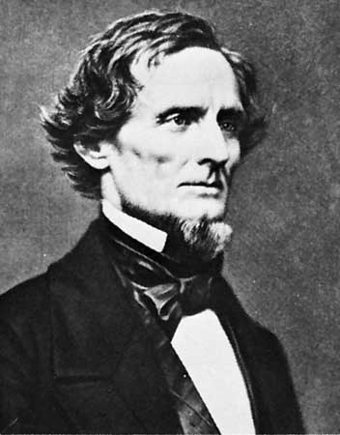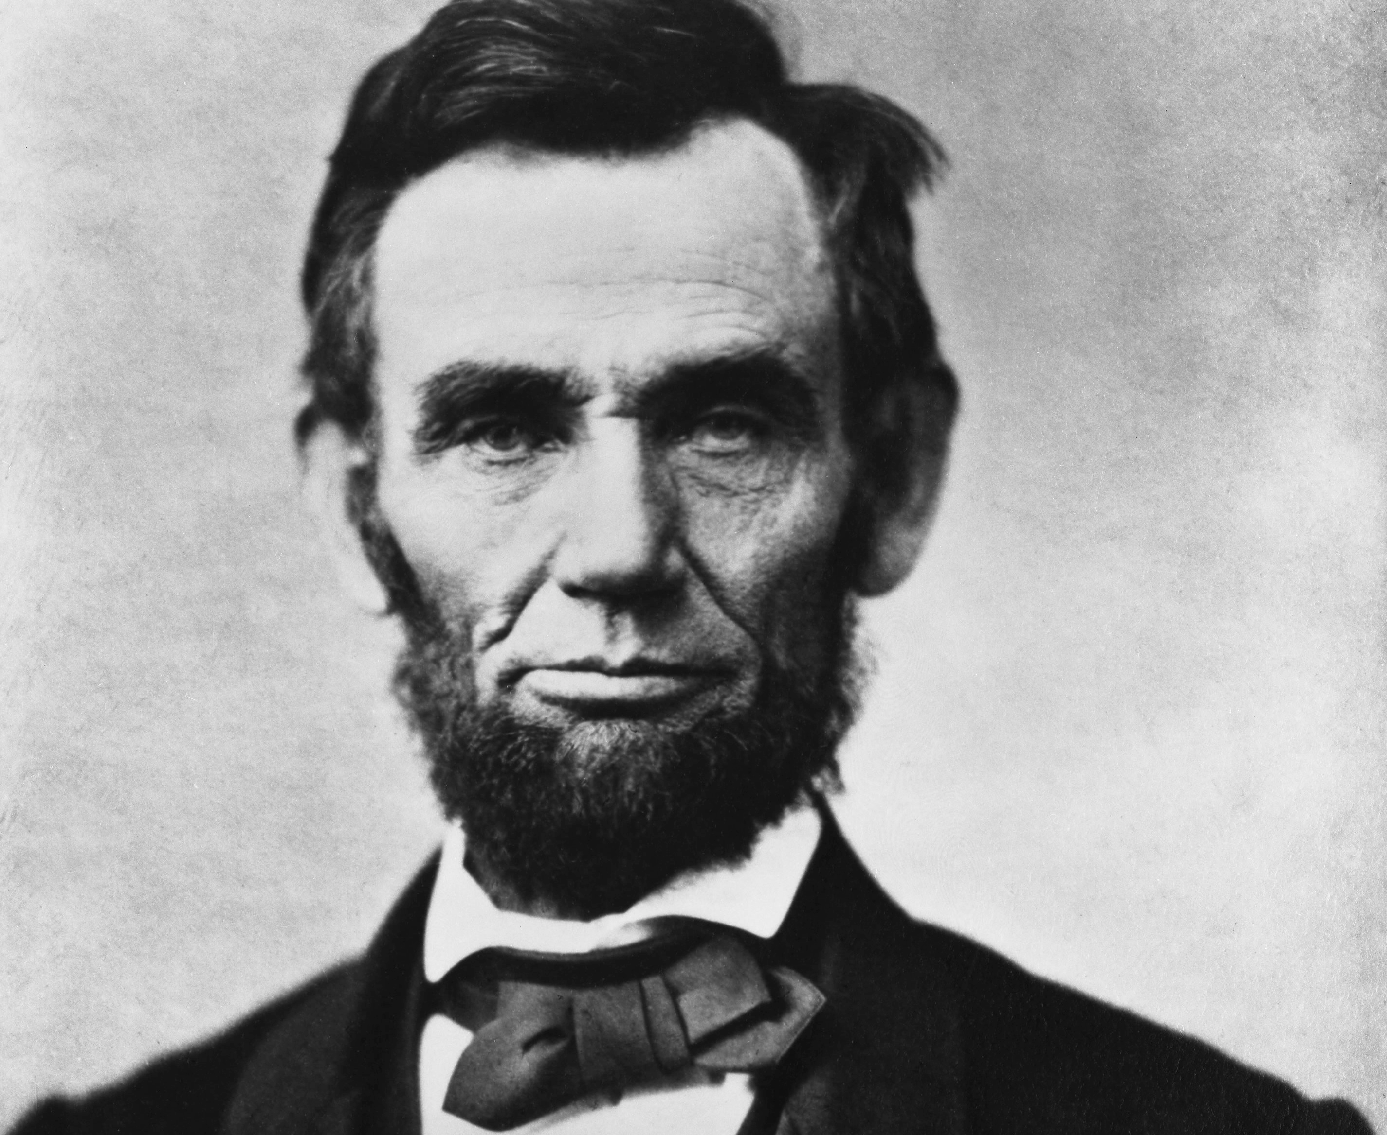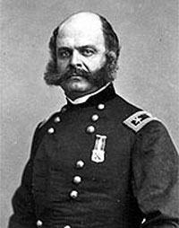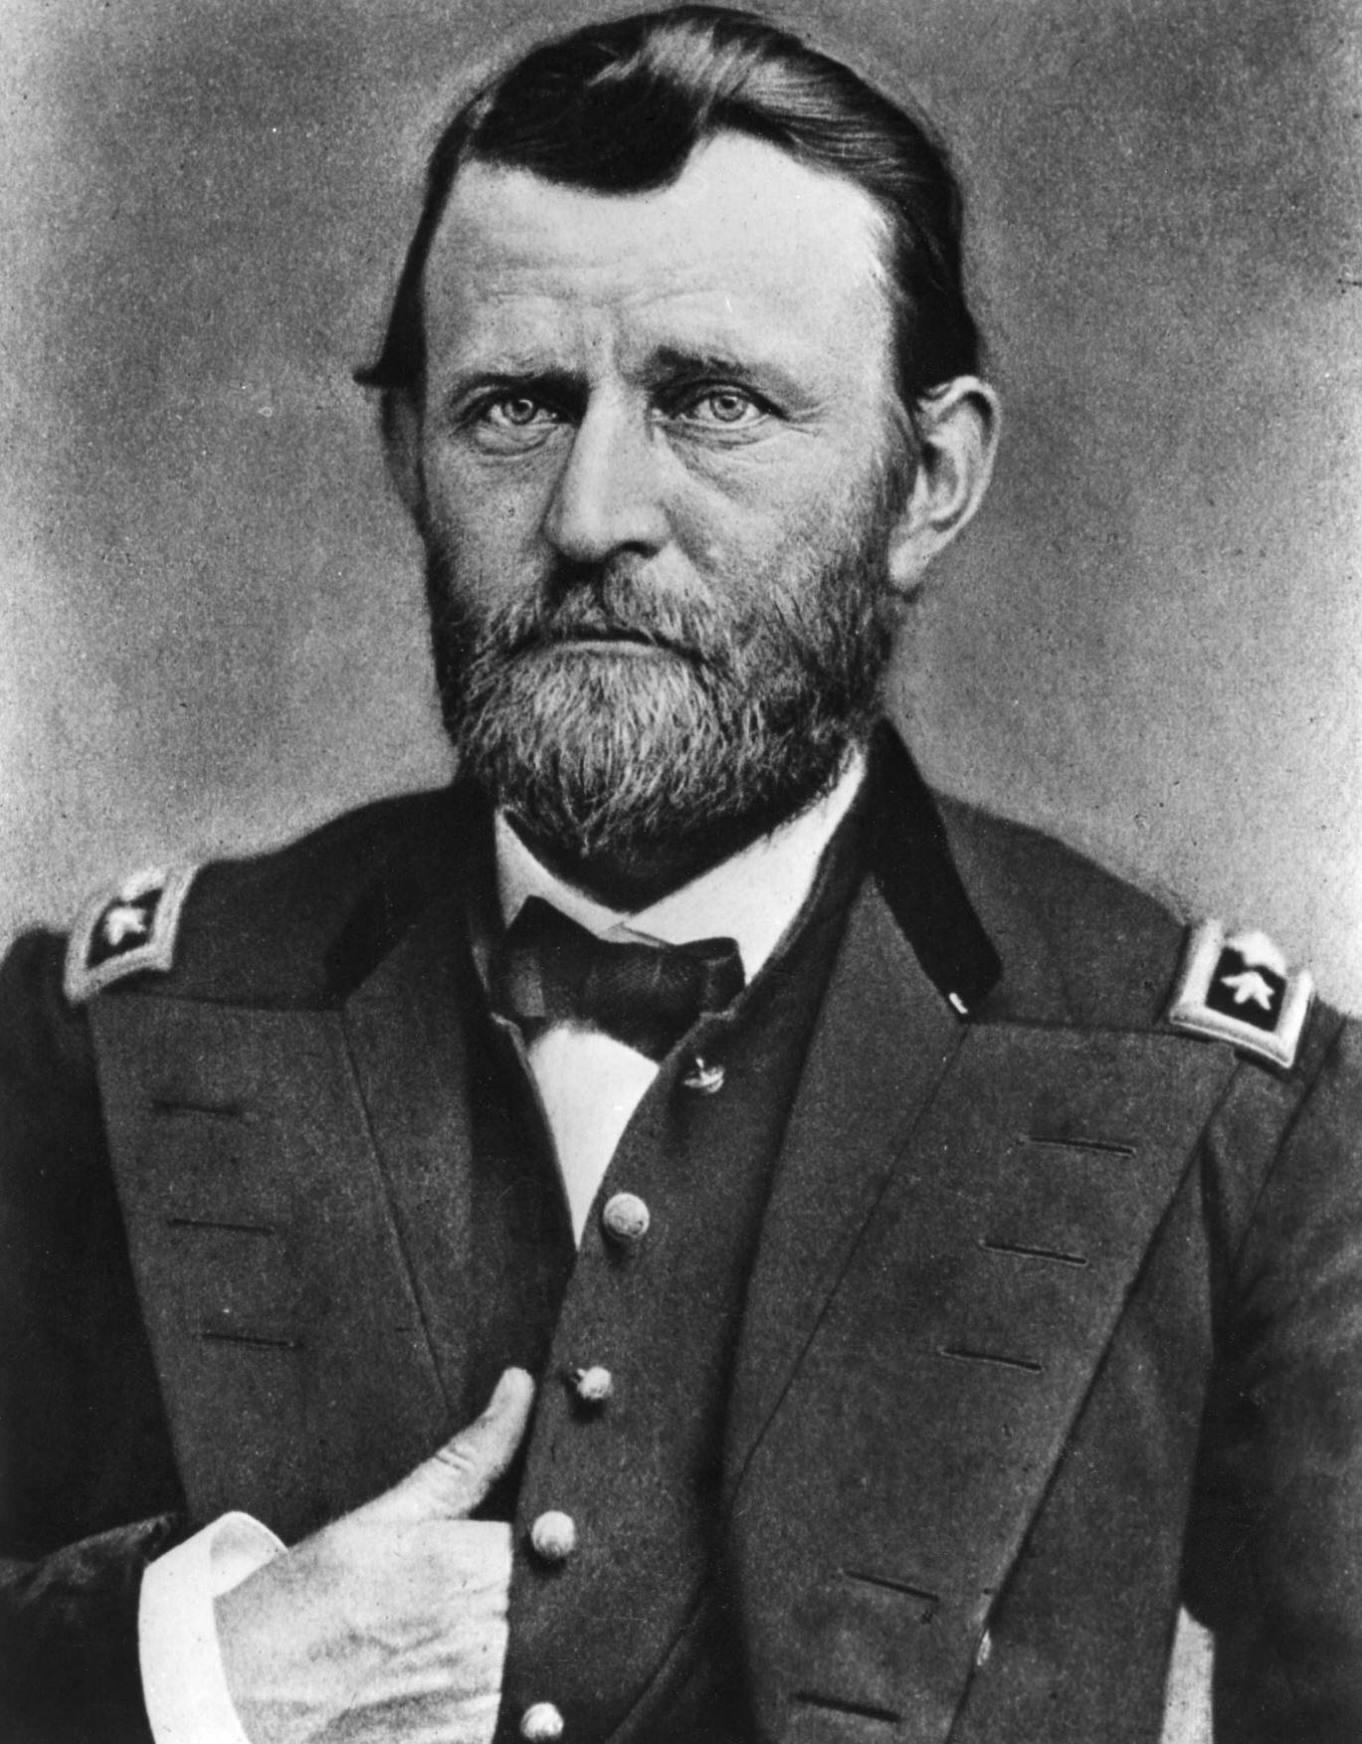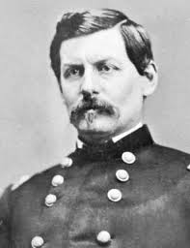
Jefferson Davis Abraham Lincoln Ambrose Burnside Ulysses S. Grant George McClellan
Confederate President US President Union General Union General Union General
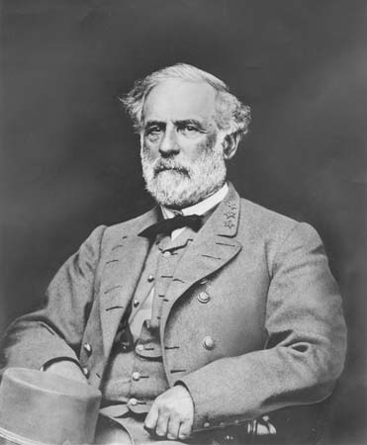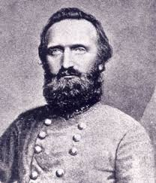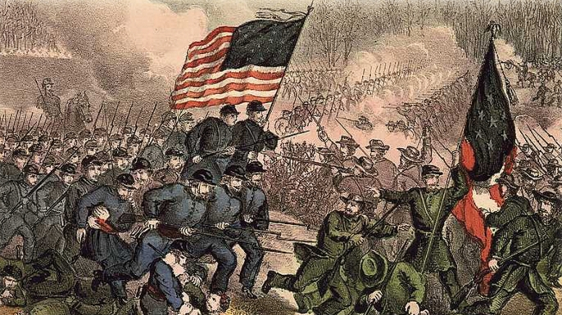
Robert E. Lee Stonewall Jackson Battle of Bull Run
Confederate General Confederate General
8.4: The Course of War

I. Union strategy- ________________ southern ports, seize Richmond, VA- southern capital, seize control of the Mississippi River
II. Confederate strategy- fight a defensive war until the North grew tired and gave up and wanted European help
III. Battles 1861-1862
A. Battle of __________- (Manassas) July 1861- Union troops thought there would be an easy
victory-citizens went to watch- Confederates defeated union- both sides needed training
B. General McClellan trained Union soldiers- too cautious –not aggressive
C. USS Merrimack renamed Virginia vs. USS Monitor- 2 _______________ ships- no winner
D. September 1862- Battle of ____________- near Antietam Creek in Sharpsburg, Maryland-
23,000 soldiers died- Confederate General Robert E. Lee withdrew his troops, so the
Union claimed victory. Neither side was a clear winner.
E. General Ambrose Burnside replaced General McClellan as the leader of the Union
troops in the East.
IV. Battles late 1861-1863
A. Dec. 1862 Confederate General Lee defeats Union General Burnside at Fredericksburg
B. May 1862 Confederate Generals Jackson and Lee defeat Union troops at the
Battle of Chancellorsville- Jackson was killed
V. In the West, Union General Ulysses S. _________ successful- 1862 captured Fort Henry and Fort Donelson, Union won the bloody Battle of Shiloh, then captured New Orleans and Memphis- the Confederates lost control of the ______________________________

8.5: Emancipation and Life in Wartime

I. Mid-1862- Lincoln freed the slaves in Confederate territory- but not in the 4 border slave states that didn’t leave the union or in captured areas
A. Slaves were laboring in Confederate states- helping grow food, worked in mines etc…
B. _____________ Proclamation January 1, 1863- Europeans now less likely to help the South
C. 1862 the Union repealed the law forbidding African Americans from fighting- many
free African Am. and escaped slaves joined the Union side in all black units with less pay
D. By 1863 African Americans were fighting in major battles and by 1864 all
soldiers received the same ______
E. ________ Massachusetts Regiment- all black unit- courageous- William Carney- 1st black
to receive the Congressional Medal of Honor
F. Slaves kept working in the South, but fled once Union armies reached their area
II. Many soldiers under 21 yrs. old- marched, trained, slept on ground, inadequate clothing, no shoes,
crude medical care, __________________, poor sanitation, disease
A. South drafted 17-50 year olds
B. ____________________ Prison Camp in Georgia- Union prisoners starved, diseases
C. 1 out of 7 Union soldiers deserted, 1 out of 9 Confederate soldiers deserted
III. Union draft- all able bodied men 20-45 were required to serve if called, could avoid the draft
by paying $300 or hiring someone to serve in your place
A. Many angry- poor men fighting for the rich
B. _____________ riots- why fight to end slavery? who cares? 14,000 arrested during the war
C. Confederate draft- men owning 20 slaves or more not drafted- in the end a few thousands
slaves fought for the Confederacy
D. The Union enacted ___________ tax in 1861 to pay for the war, issued bonds, printed money so inflation
E. Farm production increased during the war- farmers bought machines, demand for clothing
shoes, guns, and other goods from the North
F. The South’s _______________ ruined- shortages, loss of cotton trade, cost of war
G. South- income tax, printed money so inflation, shortages due to Union blockade (food)
IV. Women contributed to war effort- worked in factories or on farms while the men fought, some
disguised themselves and fought, raised families by themselves, served in army camps,
helped supply food, clothing, bedding, medicine, __________________

8.6: The War’s End

I. In July 1863, the tide of the war turned against the South
A. July 1863 the Union defeats the Confederates after several tries at the Battle of Vicksburg-
split the Confederate army from east and west
B. July 1863- the Union defeated the South at the Battle of _________________- huge losses
C. Nov. 1863- Gettysburg Address when dedicating a cemetery for the fallen soldiers
II. Lincoln appointed General __________ as __________________ of Union forces in 1864.
A. Grant ordered total __________ against the South.
B. Southern civilians suffered from lack of ________ and ________________.
C. Union General Sheridan destroyed crops, farms, and livestock on his march in 1864.
D. Union General Sherman captured Atlanta in Sept. 1864- tore up railroads, burned
farms, barns, homes, bridges, and factories
III. ______________ wins the Presidential election in 1864- inaugural speech- liberty, equality, union,
and government
IV. Union General Grant successful through 1864 pressing on replenishing troops and supplies
A. 1865 Grant takes Petersburg and Richmond
B. Grant traps Lee in ____________________________________.
C. Confederate General Robert E. Lee surrenders at Appomattox Court House April 9, 1865
D. Grant lets the Confederate soldiers leave and return to the South
E. Medal of _____ signed into law during the Civil War- highest honor- 1,500 soldiers awarded
V. The Civil War 1861-1865- more than 360,000 Union soldiers and 250,000 Confederate
soldiers lost their lives. The war cost about $20 billion.
A. The _____________ government’s power grew.
B. The war ended ______________.

