Name ___________________________ Hr. _____

Proclamation of 1763
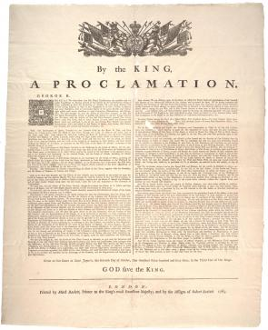

After the conclusion of the French and Indian War in America, the British Empire began to tighten control over its rather autonomous colonies. This royal proclamation, which closed down colonial expansion westward, was the first measure to affect all thirteen colonies. In response to a revolt of Native Americans led by Pontiac, an Ottawa chief, King George III declared all lands west of the Appalachian Divide off-limits to colonial settlers. The edict forbade private citizens and colonial governments alike to buy land from or make any agreements with natives; the empire would conduct all official relations. Furthermore, only licensed traders would be allowed to travel west or deal with Indians. Theoretically protecting colonists from Indian rampages, the measure was also intended to shield Native Americans from increasingly frequent attacks by white settlers.

Colonial Currency Act 1764

Definition of the 1764 Currency Act
The 1764 Currency Act was a law passed by British Parliament to regulate the issue and legal tender status of paper money in the colonial economy. This act was an extension of the 1751 Currency Act that applied to New England colonies, the 1764 Currency Act applied the same principles to all British colonies in America.
British law banned the minting of coins and the issue of official government money in America. To avoid this restriction colonial governments issued “bills of public credit”, legally not official money. Bills of credit were backed by tax collection and privately, by land and property.

Sugar Act 1764
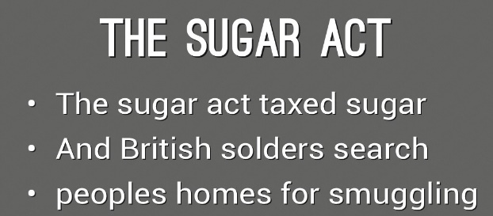
The American Revenue Act of 1764, so called Sugar Act, was a law that attempted to curb the smuggling of sugar and molasses in the colonies by reducing the previous tax rate and enforcing the collection of duties. It added several products such as hides, skins and potash to the list of enumerated commodities that could be legally exported under the Navigation Acts. It was introduced by the new British Prime Minister, George Grenville. The 1764 Sugar Act amended the existing 1733 Sugar and Molasses Act.

The goal of this law was threefold. First, the British realized that smuggling was close to endemic and that the rule of law was being undermined by illegal trade. Second, protecting British trade by introducing new trade restrictions following the established Navigation Acts. Three, the French Indian War had taken a toll on British finances and Americans had to pay for their own protection. With these objectives in mind, the Sugar Act was designed to crack down colonial trade with countries other than Britain, especially France and Spain with colonies in the West Indies while increasing revenue to pay British debt.

The Stamp Act 1765
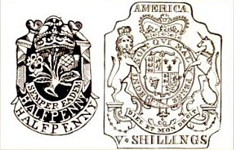
The Stamp Act was a tax imposed by the British government on the American colonies. British taxpayers already paid a stamp tax and Massachusetts briefly experimented with a similar law, but the Stamp Act imposed on colonial residents went further than the existing ones. The primary goal was to raise money needed for military defenses of the colonies.
This legislative act was initiated by the British Prime Minister George and adopted by the British Parliament. The decision was taken on March 1765 but did not take effect until November 1st of the same year.

The Act imposed a tax that required colonial residents to purchase a stamp to be affixed to a number of documents. In addition to taxing legal documents such as bills of sale, wills, contracts and paper printed for official documents, it required the American population to purchase stamps for newspapers, pamphlets, posters and even playing cards. The tax was payable in scarce silver and gold coins and not in paper money which was the most common method of payment in the colonies. According to Oliver M. Dickerson, more than one hundred thousand pounds worth of stamps were shipped to America.
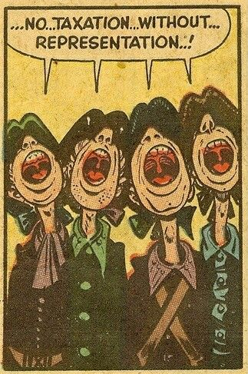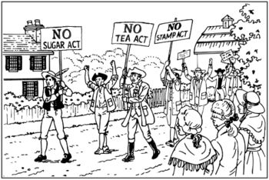

1765 – Quartering Act
The first in the series of Quartering acts passed by the British parliament. Also known as the American Mutiny Act, The Quartering Act of 1765 was passed on May 3rd, 1765 and required colonial assemblies to provide housing, food and drink to British troops stationed in their towns with the purpose of improving living conditions and decreasing the cost to the crown. This act was implemented by General Tomas Gage, the commander in chief of North America. Soldiers were to be housed in barracks or empty public buildings and not in private residences. It was the duty of local legislatures to fund the expenses.

Most colonial legislatures agreed to the new law even though the expense to fund the troops was seen as a tax. In January 1766 the New York assembly refused to raise the money. New York was the main port of arrival and departure of soldiers and the burden to finance housing was heavier on them than on any other assembly. Parliament passed the New York Suspending Act on July 1767 which suspended the assembly until they complied with the new law. The New York assembly decided to provide limited funding for housing and food.
The Quartering Act was scheduled to be modified every two years. In 1767 its provisions were modified slightly to include public houses and unoccupied homes. The only known violent conflict occurred in January 1770 in the Battle of Golden Hill when the New York legislature voted to fund the troops.

The Declaratory Act 1766
The Declaratory Act was a measure issued by British Parliament asserting its authority to make laws binding the colonists “in all cases whatsoever” including the right to tax. The Declaratory Act was a reaction of British Parliament to the failure of the Stamp Act as they did not want to give up on the principle of imperial taxation asserting its legal right to tax colonies.
When Parliament repealed the Stamp Act on March 1766, it concurrently approved the Declaratory Act to justify its repeal. It also declared all resolution issued by the Stamp Act Congress null and void. This act meant that a Parliamentary majority could pass any law they saw fit affecting British subjects and colonists alike.

Townshend Acts – Original Text 1767
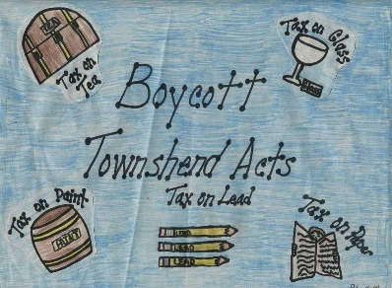
A series of measures introduced into the English Parliament by Chancellor of the Exchequer Charles Townshend in 1767, the Townshend Acts imposed duties on glass, lead, paints, paper and tea imported into the colonies. Townshend hoped the acts would defray imperial expenses in the colonies, but many Americans viewed the taxation as an abuse of power, resulting in the passage of agreements to limit imports from Britain. In 1770, Parliament repealed all the Townshend duties except the tax on tea, leading to a temporary truce between the two sides in the years before the American Revolution.

Tea Act 1773
The Tea Act, approved by the British Parliament on May 10, 1773, actually placed no new tax on tea and was not designed to increase revenue. It was intended to benefit the East India Company by giving them the exclusive right to sell tea in the colonies, creating a monopoly which the colonists perceived as another means of “taxation without representation”. In addition to granting the monopoly of the American tea market to the East India Company, they were also exempt from paying British duty by directly shipping the commodity to the American colonies.

Interestingly one of the intentions of The Tea Act was to lower the price of tea in the colonies by eliminating the merchant middleman. As the Tea Act allowed the tea to be shipped directly to the colonies the price of tea became 9 pence per pound cheaper even with the 3 pence per pound tax retained from the Townshend Duties. In addition the act allowed the East India Company to choose its distributors or special consignees thus creating opposition among local merchants and shopkeepers

Intolerable Acts (Coercive Acts) of 1774 facts
The Intolerable Acts also known as Coercive Acts were a package of five laws implemented by the British government with the purpose of restoring authority in its colonies. The first four Acts were passed as reprisal for the rebellion against the 1773 Tea Act that led to the Boston Tea Party Protest.
The first act was The Boston Port Act which came into effect on March 31, 1774; it closed the port of Boston until the East India Tea company was repaid for the destroyed tea. All shipping, landing or discharging of goods was prohibited in the area within the Boston harbor. This act intentionally punished all the residents of Massachusetts rather than those responsible for the destruction and economic loss during the Tea Party Protest. Original text of The Boston Port Act.
Boston Port Act | An act to discontinue, in such manner, and for or such time as are therein mentioned, the landing and discharging, lading or shipping, of goods, wares, and merchandise, at the town, and within the harbor, of Boston, in the province of Massachusetts Bay, in North America.
Massachusetts Government Act | An Act for the better regulating the government of the province of the Massachusetts Bay in New England.
Administration of Justice Act | An act for the impartial administration of justice in the case of persons questioned for any acts done by them in the execution of the law, or for the suppression of riots and tumults, in the province of the Massachusetts Bay, in New England.
Quebec Act | An Act for making effectual Provision for the Government of the Province of Quebec in North America.

Two of the Four Intolerable Acts- 1774
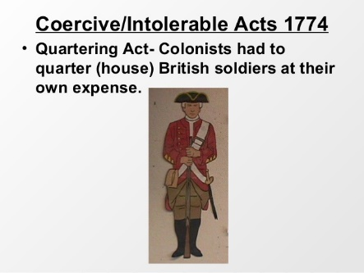
The Quartering Act effective June 2, 1774 had the same purpose as the previous Quartering Act of 1765. It mandated colonies to house British soldiers, but this time gave the governor rather than the assembly the authority to do so. Soldiers were to be housed in uninhabited houses, barns, outhouses or buildings that the governor thought necessary to be taken for the purpose of sheltering soldiers. Original text of the Quartering Act of 1774.

The Quebec Act established on June 22, 1774 enlarged the boundaries of the Province of Quebec and passed reforms favorable to the catholic French majority to boost their loyalty in the face of growing resistance in the New England colonies. However his act did not allow them to elect a legislative assembly.

Colonists reaction:
The colonies reaction to many of the Acts imposed by Britain was to boycott British goods.

A cry of “No Taxation Without Representation” was important to the colonists.

Throughout the colonies, the message was clear: what could happen in Massachusetts could happen anywhere. The British had gone too far. Supplies were sent to the beleaguered colony from the other twelve. For the first time since the Stamp Act Crisis, an intercolonial conference was called.

It was under these tense circumstances that the First Continental Congress convened in Philadelphia on September 5, 1774.

