Battle of the Somme: 1 July - 13 November 1916
One hundred and twenty-five miles northwest of Verdun, the British and French armies joined at the Somme River. A Franco-British offensive was planned here for 1916 to relieve pressure on the French at Verdun. British General Douglas Haig ordered a massive bombardment of the German lines that would last a week and could be heard across the Channel in England. But the German troops were deeply dug in and the bombardment did not reach them. Once the shelling was over, of the 100,000 British troops who attacked the German lines July 1, 1916, 20,000 were killed and over 40,000 were wounded. It was the single worst day in deaths and casualties in British military history. Eventually this battle, which did not change the front line trenches much at all, involved over 2 million men along a 30 mile front. British and French losses numbered nearly three-quarters of a million men.

Many 'Pals' Battalions, comprising men from the same town, had enlisted together to serve together. They suffered catastrophic losses: whole units died together and for weeks after the initial assault, local newspapers would be filled with lists of dead, wounded and missing.
The French advance was considerably more successful. They had more guns and faced weaker defences, yet were unable to exploit their gains without British backup and had to fall back to earlier positions.
With the 'decisive breakthrough' now a decisive failure, Haig accepted that advances would be more limited and concentrated on the southern sector. The British took the German positions there on 14 July, but once more could not follow through. The next two months saw bloody stalemate, with the Allies gaining little ground. On 15 September Haig renewed the offensive, using tanks for the first time. However, lightly armed, small in number and often subject to mechanical failure, they made little impact.
Torrential rains in October turned the battlegrounds into a muddy quagmire and in mid-November the battle ended, with the Allies having advanced only 8km (five miles). The British suffered around 420,000 casualties, the French 195,000 and the Germans around 650,000. Only in the sense of relieving the French at Verdun can the British have claimed any measure of success.
http://www.pbs.org/greatwar/maps/maps_somme.html
http://www.bbc.co.uk/history/worldwars/wwone/battle_somme.shtml
http://www.youtube.com/watch?v=FvYIIuxh2kY
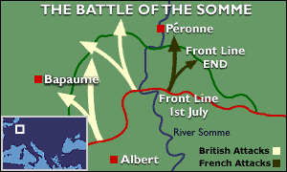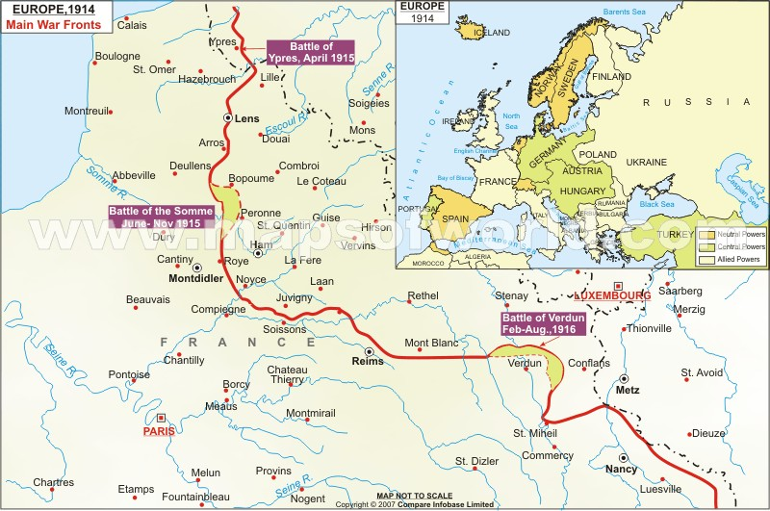
Battle of the Somme
July 1-Nov. 13, 1916

General Douglas Haig
Field Marshall Douglas Haig is most associated with the Battle of the Somme in World War I. Douglas Haig was Britain’s commander-in-chief during the Somme battle and took much criticism for the sheer loss of life in this battle.
In December 1915, Haig succeeded Sir John French as commander-in-chief of the British Army in the Western Front.Haig had little time for new military ideas. He was very much steeped in the ways that he knew – conventional tactics. In 1916, Haig put his belief in one final mighty push against the Germans to be executed in the Somme region of France. The French had been asking for some form of military assistance from the British to help them in their battle with the Germans at Verdun. Haig’s plan was to launch an attack on the Germans that would require them to remove some of their troops from the Verdun battlefield thus relieving the French in Verdun.
The Somme led to the loss of 600,000 men on the Allies side; 400,000 were British or Commonwealth troops. When the battle had ended, they had gained ten miles of land. Haig has been criticized by some for his belief in the simple advance of infantry troops on enemy lines. With 20,000 Allied soldiers killed on Day One and 40,000 injured, some historians have claimed that Haig should have learned from these statistics and adjusted his tactics. He did not. However, the Somme attack was not just about antiquated tactics as the battle witnessed the use of the rolling artillery barrage that should have helped the Allied troops as they advanced. That it did not was more a comment on the fact that the Germans had dug in more deeply than British intelligence had bargained for and was less susceptible to artillery fire. Once the artillery firing had stopped, the British had all but signaled that the infantry was on its way.
The tank was first used en masse at the Somme but it did not receive the enthusiastic backing of Haig – though many senior cavalry officers were against the tank and Haig was not alone in his suspicion of it as a weapon.
Haig served until the end of the war. He was created an earl for his leadership in 1919. He died in 1928, but spent the last few years of his life working for ex-servicemen, though primarily those who had been disabled in the war.
http://www.historylearningsite.co.uk/general_douglas_haig.htm

