7th Grade Social Studies
Notes Packet:
U.S. Constitution
Illinois Constitution
U.S. Flag

Name: ______________________________________________________________________

Hour: _____________ Date: ___________________________________

Date of Final Test: ___________________________________________________________

Introduction to the U.S. Constitution

Date the U.S. Constitution was signed __________________________________________

The two ways to become a U.S. citizen _________________ and ____________________

Three parts to the Constitution 1.
2. How many? ______
3. How many? ______

- The Preamble
- Sets the goals for the U.S. Constitution; the following ideas are included in the preamble:
- “to form a more perfect union”- all states will come together and operate as a single, united country
- “to establish justice”- all citizens will be treated equally and fairly
- “to insure domestic tranquility” – peace and order at home (in the U.S.)
- “to provide for the common defense”- national government will have an army and navy to protect its citizens
- “to promote the general welfare”- well-being for citizens; free from poverty, disease, and hunger
- “to secure the Blessings of Liberty to ourselves and our Posterity”- all Americans will have all basic rights now and in the future

- The Articles

- Three branches of government:
- ________________________________ = ______________________________ the laws
- Consist of _____________________________________
2. ________________________________ = ______________________________ the laws
- Consist of _____________________________________
3. ________________________________ = ______________________________ the laws
- Consist of _____________________________________

- Checks and Balances-> each branch can check, or _______________________, the power of another branch.

- The Amendments
- These are ______________ made to the U.S. Constitution

- The Bill of Rights are the first ten _________________________________

- The First Amendment establishes freedom of __________________________, __________________________, __________________________, __________________________, and __________________________

- Other important amendments:

- 2nd - __________________________________________________________________
- 4th -__________________________________________________________________
- 5th- __________________________________________________________________
- 6th -__________________________________________________________________
- 8th - __________________________________________________________________
- 13th -_________________________________________________________________
- 19th -_________________________________________________________________
- 26th - _________________________________________________________________

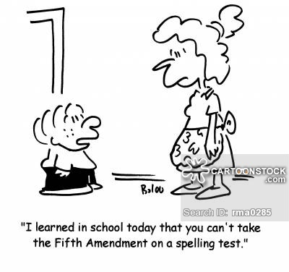

The Legislative Branch: Congress

- The legislative branch _______________________________________________ for the country.

- Ideas for bills can come from the following places: ____________________________, ____________________________, ____________________________, or ____________________________

- The two houses of Congress are:
- The House of Representatives (__________________ total members)
- Senate (___________________ total members)

The U.S. House of Representatives

- The number of representatives a state gets in Congress is based on the population of the state. This is determined by the ___________________________, which is a count of the people. This happens every ____________ years in the U.S.

- Illinois sends ________ representatives to the House of Representatives. Therefore, there are _____________ Congressional Districts in Illinois. We live in the ________ district and our U.S. Representative from the Peoria area is __________________________________.

- Each member of the U.S. House of Representatives must fulfill 3 requirements:
- _____________ years or older
- U.S. citizens for _______ years
- Resident of _____________ in which they are elected

- U.S. Representatives serve ______________ year terms and can serve an unlimited numbers of terms.

- In the Constitution, each state is guaranteed at least __________ representative.

- The sole power of the House of Representatives are:
- Start money bills
- Start impeachment process
- Select President if there is no majority in the electoral college.

- The leader of the House of Representatives is called the ________________________.
The person that currently serves in this position is ____________________________.
The U.S. Senate

- Each state sends _________ people to represent their state in the U.S. Senate. Therefore, since there are 50 states in our country, this means that there are a total number of ____________ U.S. Senators.

- Our two senators from Illinois are: _______________________ and _____________________

- Each member of the U.S. Senate must fulfill 3 requirements:
- ________________ years or older
- U.S. citizen for _________ years
- Resident of __________ in which they are elected

- U.S. Senators serve ________________ year terms and can serve an unlimited number of terms.

- The sole powers of the Senate are:
- Serve as jury for impeachment hearings
- Approve presidential treaties
- Approve Presidential nominations
- Select Vice President if there is no majority in the electoral college

- The official leader of the U.S. Senate is the ___________________________. The day to day leader of the U.S. Senate is called the ________________________________________. The person that currently serves in this position is _________________________________.

Making Laws

- Only ________________________________________ can introduce a bill in Congress.

- The three ways to vote in Congress are:
- _________________________________
- _________________________________
- _________________________________

- A delay tactic used in the Senate is called a ______________________________________

- Cloture limits a Senator to _____________________________ of debate.

- The three things the President can do with a bill are: ______________, _______________, or _______________________________________. Congress can override a presidential veto with a _____________ vote in both houses.

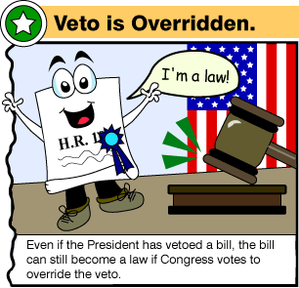 | 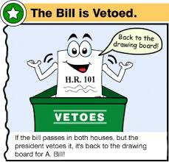

The Executive Branch: The President

- The President is head of the _____________________________________ branch.

Requirements to be President:
- _____________ years old
- Born in the __________________
- Live in the U.S. for _________________ years prior to the election

Electoral College: Elects the President; a group of electors in each state cast their votes for President; the candidate who receive a majority of the electoral votes nationwide (270) wins the election; the number of ___________________________ votes a state gets is based on the number of representatives +2 senators. How many votes does Illinois get in the electoral college? _______________
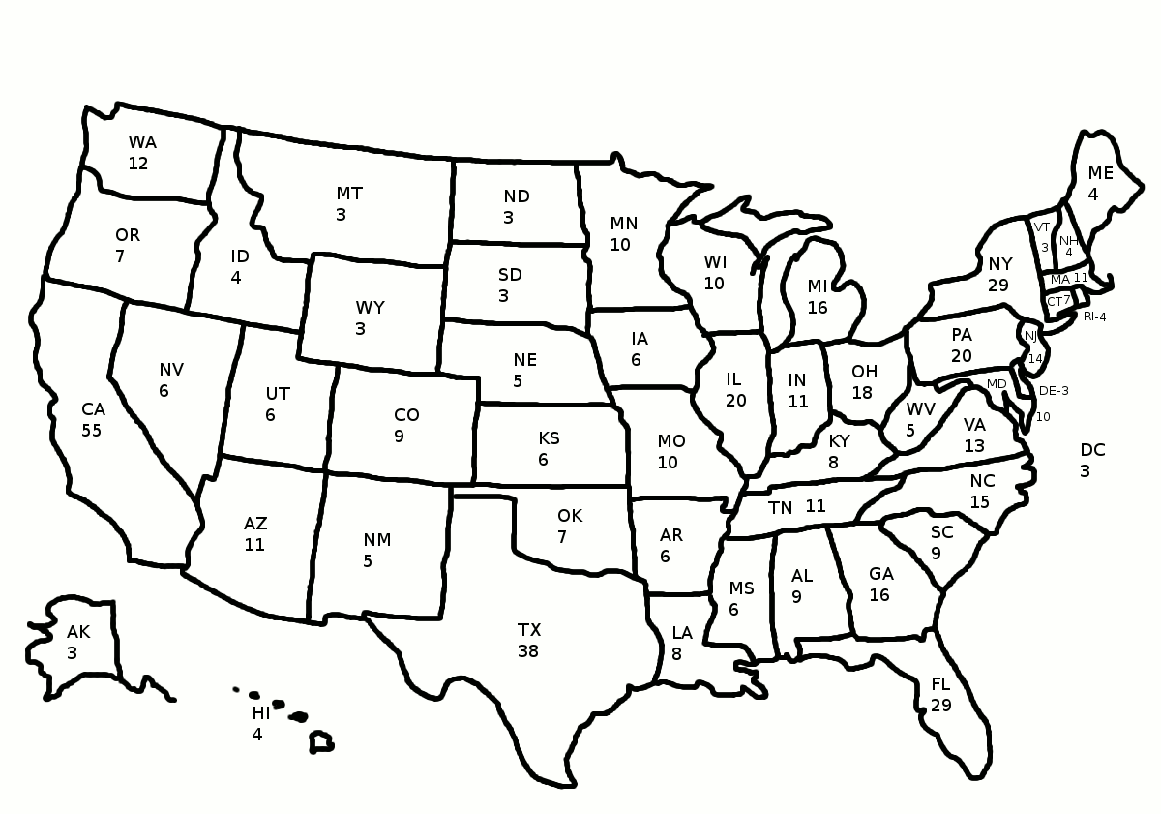

- The President serves a term of ___________ years and cannot serve more than 2 terms (22nd Amendment)

- Salary: $ _____________________ per year, plus travel expenses, free lodging in the White House, use of Camp David, and Secret Service protection for life.

- Order of Presidential Succession (used if something happens to the President):
- President- _____________________________________________________________
- Vice President- ________________________________________________________
- Speaker of the House - __________________________________________________
- President Pro Tempore- ________________________________________________
- Secretary of State- _____________________________________________________

- Cabinet: Advises the President; includes the VP, heads of executive depts., and other important officials

- The Cabinet is not mentioned in the Constitution; George Washington asked Congress to create executive departments

- There are currently _____________ executive departments. (State, Treasury, Defense, Education, Justice, Interior, H&HS, H&UD, Transportation, Commerce, Veteran’s Affairs, Energy, Labor, Agriculture, and Homeland Security).

- The President directs foreign policy, makes treaties, and appoints ambassadors.

- The President is the ___________________________________ of the armed forces, but only ____________________________ can declare war.

- The President has the power to:
  - Grant a __________________________-> Forgiveness and freedom from punishment
  - Grant a __________________________-> Similar to a pardon, but for a group of people instead of an individual
  - Grant a __________________________ -> an order to delay a person’s punishment
- The ________________________________________ (NSC) helps the President make life and death decisions about the safety and security of the U.S.

E Plurbus Unum means “________________________________”

The Judicial Branch: The Courts

- The two types of court causes are:
- ________________________________- cases in which juries decide whether people have committed crimes (murder, robbery, etc.)
- ________________________________- cases in which two sides disagree over some issue (examples: lawsuits over injuries, money, property, etc.)

- The two types of courts are:
- _________________________________
- _________________________________

- The three levels of federal courts (from lowest to highest):
- ____________________________ - most of the work of deferral courts is done here; evidence is presented during trial and a jury decides the facts of the case; if someone disagrees with the decision, they can appeal it, or ask the decision to be reviewed by a higher court
- ___________________________ - judges review decisions of the district courts
- ___________________________ - “the court of last resort”- no appeal from the Supreme Court

U.S. Supreme Court

- Hears appeals from lower courts that involve federal laws (about 100 cases per year)

- Uses ____________________________________- Review of any law to see if it agrees with the Constitution

- 9 total justices; 1 Chief Justice (____________________________________); 8 Associate Justices

- President appoints the justice, but the Senate must approve them; justices serve for life

- First female justice- Sandra Day O’Connor (now retired)

More Court Terms
- ____________________________________-> a court order requiring someone to appear in court
- ____________________________________-> issues court orders and determines whether cases should be brought to trial
- ____________________________________-> arrest suspects, delivers defendants to court, and serves subpoenas

Illinois Government

- The State of Illinois also has three branches of government: legislative, executive, and judicial

- Illinois was the _____________ state to be admitted into the Union. It was admitted on _________________________________.

- The 3 capital cities of Illinois in chronological order are:
- _________________________________
- _________________________________
- _________________________________

- There are ______ counties is Illinois and we live in ________________________ County.

Executive Branch

- The head of the executive branch in Illinois is the _______________________________.

- The governor of Illinois is ________________________________________.

- The requirements to be the governor are:
- ________________ years old
- ________________ citizen
- live in the state for ______________ years before the election

- Other individuals in the executive branch of Illinois are:
  - Lieutenant Governor- __________________________________________
  - Attorney General- _____________________________________________
  - Secretary of State- ____________________________________________
  - Treasurer- __________________________________________________

Legislative Branch

- The law making body in Illinois is called the ___________________________________

- The three requirements to be a member of the Illinois General Assembly are:

- ______________ years old
- ______________ citizen
- live in the district being represented for at least _________ years prior to election

- Illinois 18 has Congressional districts. We live in the ____________ district, and our U.S. Representative is _______________________________________.

- There are ____________ Representative Districts in Illinois. We live in the __________ district, and our State Representative is _____________________________________.

- There are ____________ Legislative districts in Illinois. We live in the ______________ district, and out State Senator is ____________________________________________.

- Our two U.S. Senator from Illinois are _________________________ and ____________________.

Judicial Branch

- The Illinois Supreme Court consists of __________ justices. They serve __________ year terms.

State Symbols

State Mineral= ______________________________ State Insect= _____________________________
State Slogan= ______________________________ State Flower= ____________________________
State Animal= ______________________________ State Tree= ______________________________
State Bird= ______________________________

U.S. Flag
- The origin of the U.S. flag date back to the ___________________________________ War.
- The blue field on the flag is called the ______________________.
- There are __________ red stripes and ______________ white stripes on the U.S. flag. These stripes represent the _____________________________________________________.
- The U.S. flag has _____________ stars, which represent the ____________________.
- The 50 star flag has been used since _____________________.
- The flag should only be displayed from _______________________ to ____________________ in decent weather conditions.
- The 2 proper ways to destroy a flag are to __________________ or ___________________ it.
- The flag should never touch the ground, be used as a covering or drapery. It should never be sued to hold, carry, or deliver anything.

