Name ____________________
European Map 40 points Date _____________ Hr. ____
Use pp. 874 and 1044-1045
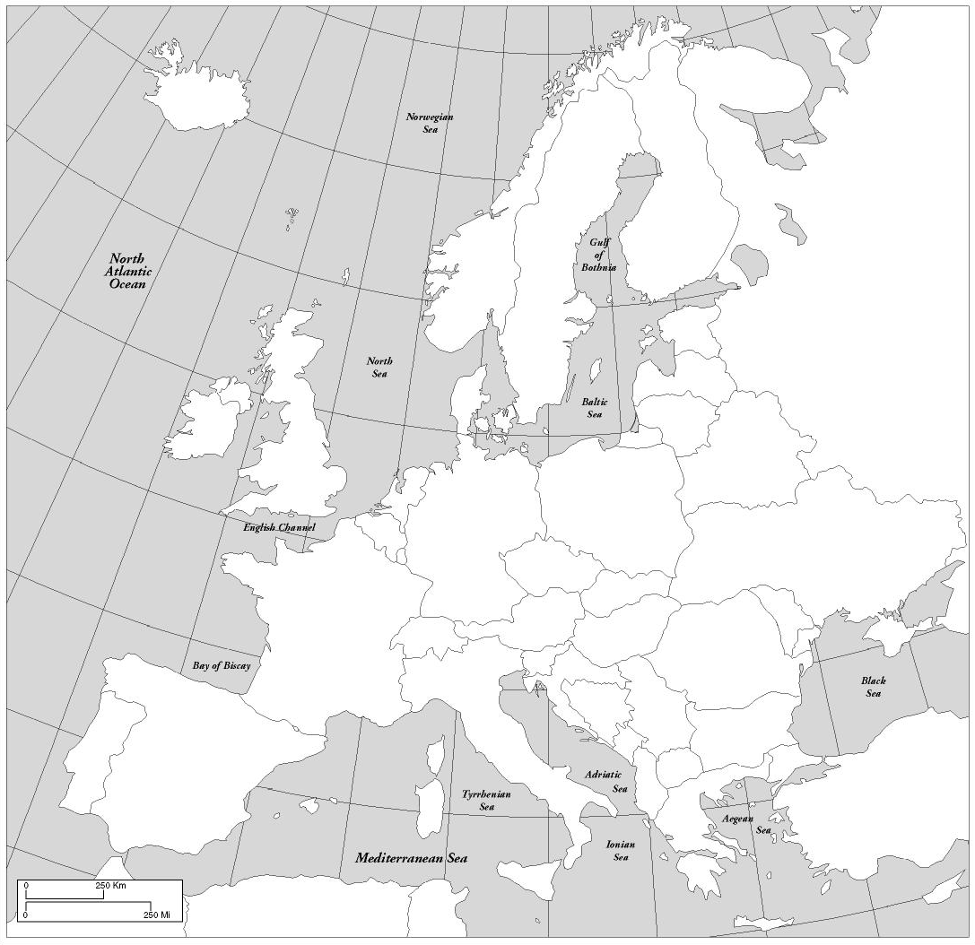

Label the 38 European countries shown above. You may abbreviate. 2 points neatness

Do not put the numbers below and label. No coloring necessary.

