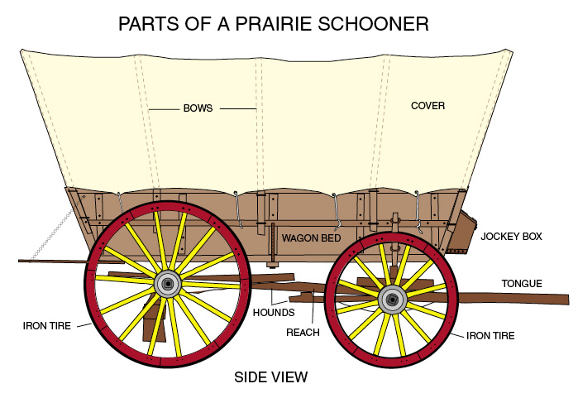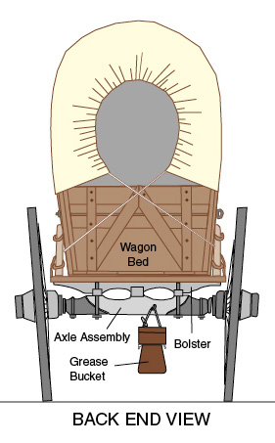

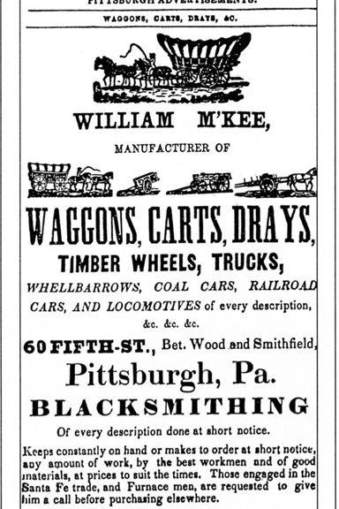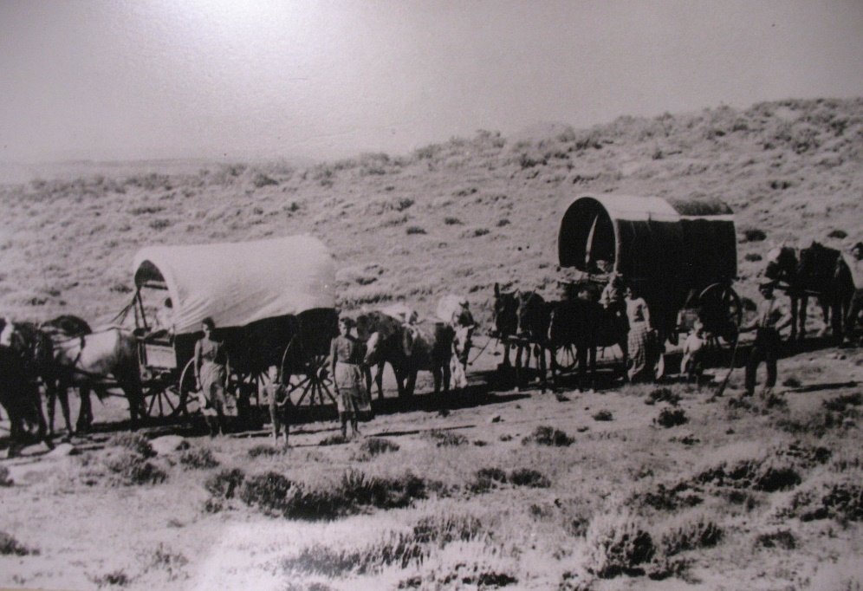

Death and disaster lurked everywhere along the Oregon Trail. Wagon tongues and axles broke with maddening regularity, forcing emigrants to fashion new ones on the spot from whatever trees could be felled in the immediate vicinity. In barren country finding a good tree could slow an emigrant party for days. Carrying spare tongues or axels was out of the question as they added too much weight, slowing progress, and the emigrants had a need for speed.
They had a short window. They generally left Missouri in May and strove to get through the Rockies before October. Too long a delay would put them in the mountains as the snow began to fall, and as the Donner Party discovered to their everlasting horror, winter in the mountains could be a death sentence.
River crossings were perilous. Fast flowing rivers could smash a wagon to splinters. Steep descents were nerve-wracking. Wagons didn’t have brakes and so had to be lowered by ropes. One slip and it was over.
A wagon damaged beyond repair would have to be abandoned, throwing the travelers on the mercy of their fellows, adding to the friction that inevitably occurs in close quarters over long periods of time. Quarrels were common. Fights broke out, adding another potential source of injury. An injured or sick traveler was a burden, not only because his loss removed a hand needed to perform work but because he added unwanted weight to the wagon if his injuries were such that he had to be carried.
Snake bites, diseases and Indian attacks were other sources of potential disaster. But in spite of all this, most settlers made it through.

