The Trail of Tears Mrs. Brooks - example
Exhaustion, starvation, and mistreatment caused the deaths of approximately 4,000 Cherokee Indians on the infamous Trail of Tears. The Cherokee Nation was forcibly moved from Georgia and the surrounding area to a reservation in the Oklahoma Territory. Chief John Ross followed all of the right steps. He appealed all the way to the Supreme Court, fighting the Indian Removal Act, so the Cherokee could stay on their homeland. The Supreme Court sided with the Cherokee. President Andrew Jackson ignored the ruling and sent the U.S. Army to round up and move the Cherokee in the winter of 1838-1839. Most Cherokee walked to their new home and thousands died making the difficult trip.
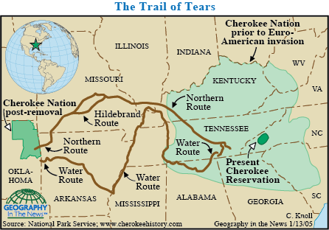
Trail of Tears route from 1838-1839
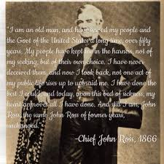
Chief John Ross appealed to the Supreme Court
hoping the Cherokee could stay on their homeland.
The Supreme Court sides with the Cherokee.

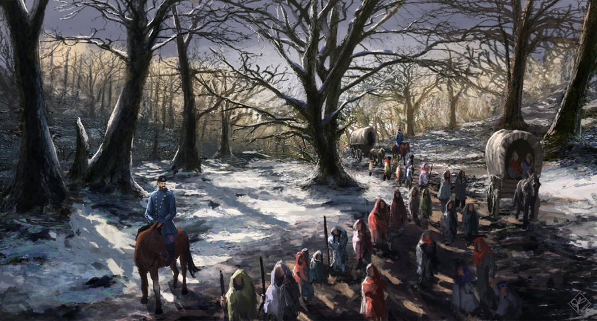
President Andrew Jackson sent the U.S. Army to forcibly move the Cherokee to the Indian Territory.

