Topic 14 WWII Notes Name___________________________

14.1: Aggression Overseas and Isolationism at Home

MOST COUNTRIES WERE IN A DEPRESSION AFTER______________ & THROUGH THE 1930’S.
I. Italy controlled by Mussolini & ________________________ party
A. governed through fear & terror
B. invaded Ethiopia
II. Germany very bitter: Hitler & _________________ Party came to power
A. Hitler- dictator- charismatic speaker- strong leader
B. __________ used as a scapegoat for Germany’s problems- deprived of citizenship
Many were sent to ________________________________- over 11 million people
perished in the camps including 6 million Jews
III. Vladimir Lenin set up a _______________________ government in the Soviet Union.
Josef ____________________: communist dictator- executed many Soviets
III. Japan military leader, __________________________ controlled country
Totalitarian state- dictatorship
A. needed natural resources
B. invaded Manchuria
IV. U.S. passed the 1935 Neutrality Acts and continued with isolationism. FDR implemented the Good Neighbor Policy withdrawing troops from Latin American- better relations
14.2: Entering the War
I. Japan invades China- bombing and killing many, threatened US controlled Philippines
II. Hitler annexed Austria, claimed Sudetenland,- 1938 ____________________ Conference-
Britain and France gave in to aggression- ____________________________________-
Nazi-Soviet Pact- agreed not to invade each other and divided up Poland- Hitler launched a _______________________ against Poland. Stalin took Eastern Poland, Finland, Estonia, Latvia, and Lithuania
III. Britain and France declared ___________ when Poland taken; September 1939
A. Italy & Japan joined Germany with 6 other countries made up _____________ Powers
B. Britain, France, Soviet Union, US and 45 other countries would make up the Allies
C. neutral countries, Spain & Switzerland, Portugal, & Ireland
IV. Hitler invaded & conquered most of Europe. Battle of __________________- blitzkrieg
V. The US ______________________, but supported the Allies
A. The U.S. could sell arms to Allies under the ______________ and _______________ Plan
B. FDR wins 3rd presidential term
C. Lend Lease Act: sold old war ships to Allies
D. Hitler invades Soviet Union, Soviets join the _______________________
E. Atlantic Charter- right of all people to form their own ____________________________
VI. Japan invading in _________________
A. Us freezes Japanese assets & property in US, oil embargo
B. Japan Bombs Pearl Harbor: __________________________- 2,400 killed
C. Us declares war on _______________, Japan’s allies declare war on US
D. The US economy turned to war time, men entered the war, & patriotic feeling
E. Japan successful in Pacific
F. Bataan Death March, Japanese capture, starve, beat, shoot US & Philippine soldiers
VII. Allied General in charge of Pacific Douglas _________________________
Allied General in charge of Europe Dwight__________________________
14.3: The Home Front
__________ million Americans served in the military.
I. Men were _____________________ and trained, both sexes volunteered. .
II. War Production Board: tanks, planes, uniforms, bullets,… . US __________________ goods, gas, food, tires, shoes, Office of Price Adminstration & people recycled- many grew _______________________ gardens
III. At home women were known as “Rosie the Riveters” – went to work in the factories
IV. African Americans
A. Executive Order 8802: outlawed job discrimination in industries with gov’t contracts
B. worked in big cities for industries
C. military ______________________, but segregation at home- Double V campaign
D. Tuskegee Airman- successful pilots
V. Discrimination at Home
A. Japanese Americans on West Coast put in _____________________________ (1942-1945)
Nisei Japanese Americans born in US- 442 Regimental Combat Team- most highly decorated military unit in US history
C. German and Italian Americans were discriminated against- curfews, travel restriction
D. Bracero Program- recruited Mexican laborers to come work in the US
14.4: Winning a Deadly War
I. Germany invaded Soviet Union in the winter of 1942.
A. turning point, fighting on 2 fronts (east and west)
B. Nazi soldiers froze, told not to retreat
C. Russian civilians paid dearly- more than one million died in the fall of Leningrad
II. Japanese successful in the Pacific at first. General in charge of the Pacific ________________
A. Japan takes the Philippines and Bataan Peninsula- Bataan Death March
B. Battle of _________________________ hurt the Japanese Navy- turning point for US
III. May 1943 Allied forces control North Africa and headed for Italy
A. Italians arrest Mussolini and execute him
B. _______________ surrenders Sept. 1943
IV. Soviets force the _______________________ to surrender at Stalingrad in 1943- pushing back
IV. June 6, __________: Operation Overlord- General in charge of Europe ___________________
A. Allied troops storm 5 beaches in Normandy, heavy Allied losses (3 million US troops)
B. Allies liberate _________________, France in August 1944
C. Battle of the ______________________- Nov. 1944- slowed Allies march to Berlin
D. FDR wins a 4th term in 1944, but dies in April 1945. Vice President Harry Truman
becomes president.
E. The Big 3 meet several times during the war: US (FDR), Britain (Churchill)
and Soviet Union (Stalin). When FDR dies Truman takes his place.
F. May 8, 1945: V-E Day= Victory in Europe: Hitler committed suicide before captured.
War in the Pacific- US strategy was _________________________ hopping
I. In the Pacific the US used ______________________ Code Talkers
Japanese pilots crashed their planes into US ships: ____________________________
US captured Iwo Jima and Okinawa- Japanese- fight to the death
II. ____________________ Bomb
A. _______________________ warned that Germany is developing a destructive weapon
B. Manhattan Project was the secret work on the A Bomb
C. July 1945, US tested A Bomb in New Mexico- main physicist ______________________
III. Should _______________________ give the OK to drop the bomb?
A. save American __________________ & money
B. didn’t want Soviet Union helping in the Pacific
C. Truman sent Potsdam Declaration to Japan gov’t about weapon of mass destruction
D. August 6, 1945: US drops A bomb on ___________________________
E. 80,00 dead & thousands injured, but no surrender
F. August 9, 1945: US drops A bomb on ___________________________
G. Japanese Emperor ____________________ demanded the military surrender
H. __________ Day- August 14, 1945- official surrender Sept. 2-aboard USS Missouri
lV. Aftermath of deadliest war in history 30-60 deaths- fought on land, sea, and in ________
A. ______________ Death March- Japan captured the Philippines in 1942, forcing 75,000
American and Filipino soldiers to march 65 miles- 10,000 died on the way.
B. _______________: 6 million Jews killed by Nazis & 5 million Poles, gypsies, homosexuals
disabled ect…anyone not fitting Hitler’s “Master Race” was an enemy of the state
and sent to concentration camps, some were exterminated, slave labor,
experiments, gas chambers, executions etc…
Many had nowhere to go after the war.

C. ____________________ Trials: high ranking Nazis put on trial war crimes
some executed, some imprisoned, some hid, some fled to other countries.
To the other thousands of German military personal they were told, if you know
something is morally wrong, don’t participate.
D. Japanese leaders imprisoned or executed for war crimes
V. Super Powers After the war: __________ and ____________________ (USSR)
Eastern Europe was invaded by the Soviets. Will they leave or spread communism?

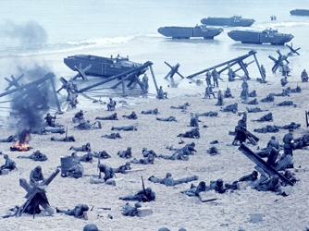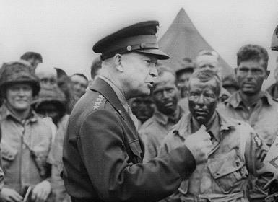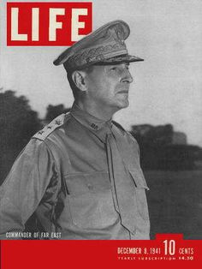
D-Day June 6, 1944 General Eisenhower General MacArthu
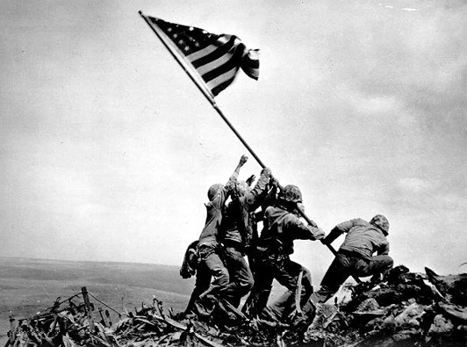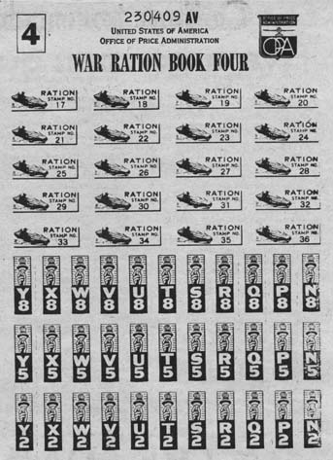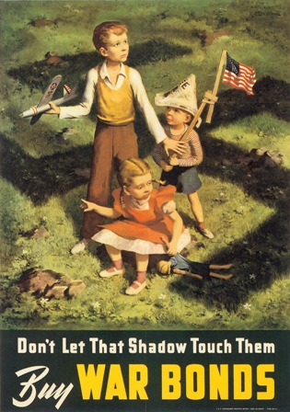
Raising the Flag at Iwo Jima Ration coupon book War Bond Poster
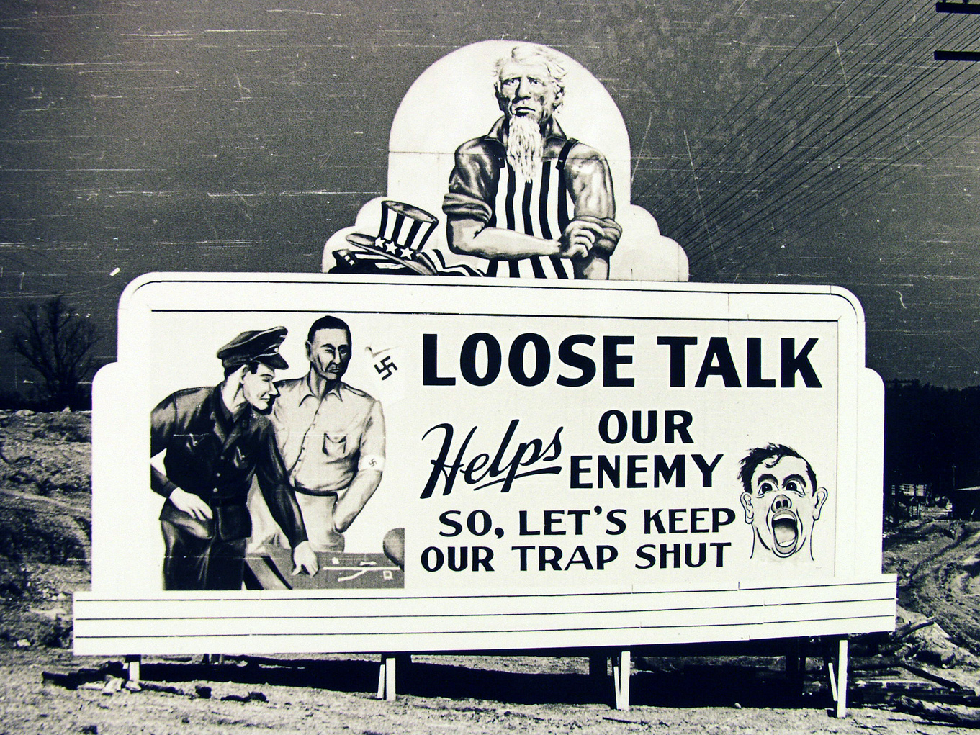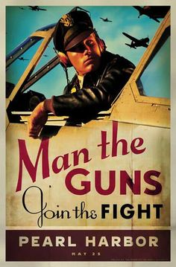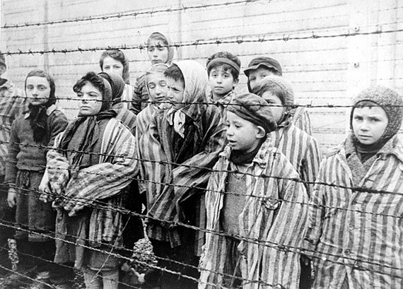
WWII poster WII poster liberating concentration camp

