Notes- 2.3, 2.4, 2.5, 2.6, 2.7 pp. 69-116 Name ___________________________________
Date ________________ Hour _____________
Topic 2.3 The New England Colonies pp. 69-82
I. Pilgrims
A. Pilgrims traveled 2 months on the ___________________ in search of religious freedom.
B. Religious wars in Europe between Catholics and Protestants.
C. People were ____________________________ for their religious beliefs.
D. Pilgrims called Separatists received Charter to set up a colony in Virginia.
- November 1620 landed in Cape Cod, Massachusetts-set up the colony of _____________
- November 11, 1620 wrote the Mayflower ____________________ on board
- Representative government and worship religion freely
II. Hardships for Pilgrims in Plymouth
- Half the settlers died from ____________________________ or disease by spring
- William Bradford chosen governor- lasted 36 years
- Help from the Native Americans-_______________________
D. First Thanksgiving because plentiful harvest helped by the Native Americans
III. Puritans-1630’s – reform the Church of England
- Charter to settle to form Massachusetts Bay Colony based on biblical teaching
- John _____________________- 1st governor of Mass. Bay Colony
- Only stockholders had a say in the government- discontented people- not represented
- Great ________________________- 15,000 people moved to the Boston area
IV. Thomas Hooker led settlers out of Mass. Bay Colony to Hartford Connecticut
- New government- Fundamental Orders of Connecticut- all male property owners could _____________________- limited the governor’s power
- Connecticut became separate colony with charter from England
- Roger Williams believed in religious tolerance – left Mass. Bay for Rhode Island
- Anne Hutchinson wanted women to have a say in church- left Mass. for ______________
V. Settlers moved throughout New England building trade and fishing villages.
A. New Hampshire became a colony
B. Some settlers treated Natives fairly, others did not
C. 1670’s ___________________ settlers in New England
D. Fighting broke out between settlers and Natives
E. 1675- King Phillip’s War- ________________ Indians attacked New England settlements
F. Other Indians allied with the Wampanoag- 600 European settlers were killed
G. Chief Metacom of the Wampanoag was killed and 1,000 Indians captured and sold into
________________________ in the West Indies
VI. New England towns
- Puritans -_______- no working, talking, etc… on Sunday & everyone had to attend church
- Town meetings- values of __________ government, individual choice, and common good
- Salem ______________ Trials- witch craft punishable by death- 20 innocent men and women executed in Salem Massachusetts
- Natives taught settlers how to grow _______________- corn, pumpkin, squash, beans
- Others dairy farmers, hunters, logging, shipbuilding, fishing industry, ironworking
- Puritans and Pilgrims and most settlers __________________________ ethic

Topic 2.4: The Middle Colonies pp. 83-91
I. Middle Colonies founded for _______________________ opportunities
A. New Netherland (Amsterdam) set up by the ________________ along the Hudson River
B. Center for commerce and trade with successful ports
C. Land grants given to wealthy families- ___________________
D. Dutch permitted all religions and ethnic groups in the colony
E. England took over New Netherland - King Charles gave it to his brother, the Duke of _____
II. New York too big- New Jersey formed
- The king gave land to people for a yearly payment- proprietary colony
- Wealthy farmland with many resources
- New Jersey- a _______________ colony with religious freedom
III. William Penn founded Pennsylvania in 1681- Quakers
- ______________- Protestant reformers wanting religious freedom- didn’t believe in war
- Pennsylvania based on religious freedom, peace, and Christian living
- Mix of political, economic, religious, and social diversity
- Enslaved ___________________ were brought to New England and the Middle Colonies
IV. Delaware formed in Penn. lower counties
V. Farmers in the Middle Colonies- wheat, barley, rye- Breadbasket Colonies- cash crops
A. Farmers had herds of ________________ and ____________________
B. Artisans- skilled craftsmen- hardware, clocks, watches, locks, guns, glass, nails, paper etc
C. Households made their every day _______________- soap, candles, food, clothing, etc…
VI. Great ________________ Road- settlers expand outside of Penn. on Indian trails
- farmed the back country- cut through forests- learned from the Natives
- Disputes and violence with some Natives- encroaching on Indian land
- No one protected ___________________ rights

Topic 2.5 : The Southern Colonies pp. 92-100
I. Maryland – 1634- ________________________ Bay
A. Lord Baltimore -religious freedom- offered land grants to people bringing servants-populate
B. Fish, oysters, crabs- successful
II. Virginia- farmers- ________________________
III. 1663- the Carolinas- North tobacco- South rice and __________________
IV. __________________- James Oglethorpe- 1732- debtors given a second chance
V. Southern Colonies – headright grant- land given to settlers- fertile land
A. Plantations- slaves brought from Africa to work- more land granted for more people/slaves
B. Easy transportation on rivers and waterways
C. Most __________ worked in the fields- others were carpenters, barrel makers, and blacksmiths. Some worked as cooks, servants, and/or housekeepers
D. Small portion of farmers had plantations- but they were wealthy.
E. Enslaved workers faced hardships- impoverished houses, denied basic _______________
F. Backcountry- near Appalachian Mountains- rich soil- farmers were self sufficient
VI. Slave Trade
A. First enslaved Africans came in 1619 to Virginia- Southern Plantations relied on slave labor B. Slave traders from Europe set up posts in Western Africa offering _________ and other goods for enslaved Africans.
C. Demand for __________________ labor in South.
VII. Passage across the Atlantic for Slaves- ________________ Passage
- Enslaved Africans were crammed into the hull of a ship.
- Chained together, _______________ spread rapidly, treated inhumanely like animals
- Occasional mutiny or revolt or suicide
- 10% died on the passage
- Once in the US, slave codes were in place to prevent rebellions- slaves were like property
- Slavery- racism with out basic ___________________ rights

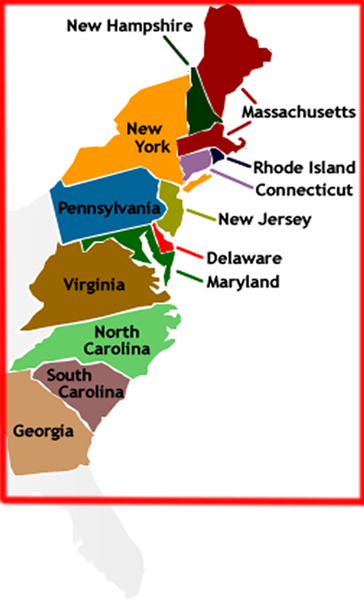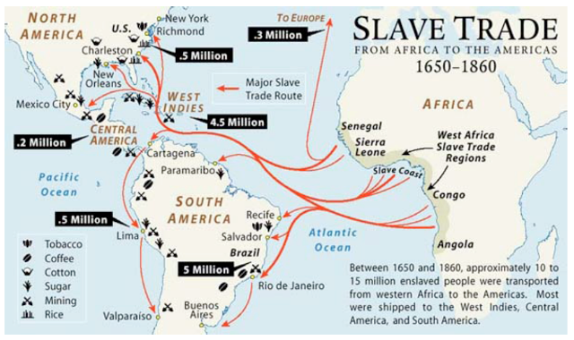

Topic 2.6: Colonial Society pp. 101-111
I. Colonial Society differences- person’s _____________ and wealth determined social status
A. __________ class- gentry- wealthy planters, merchants, ministers, lawyers, royal officials
B. ______________ class- farmers, craftsmen, & trades people
C. Lower class- hired farm hands, indentured servants-paid passage over for 4-7 yrs. service
II. Most colonists in country were farmers, corps & livestock- hardworking- traded/sold extras ________________- milked cows, tended gardens, watched kids, cleaned, laundry by hand,
made clothes, candles, soap etc…
III. Colonists in cities-
A. Men- trades- butchers, shoemakers, silversmiths, printers etc..
B. Women worked with men/husbands and as maids, servants, nurses, sewing etc..
C. Educated men, bankers, lawyers, businessmen, politicians, doctors, barbers, surgeons
IV. African Influences-
- taught rice preparation
- combination of English and African languages- _____________________
- Africans worked in skilled jobs- rope or barrel making, ship building, craftsworkers
- Northern colonies both ______________ and enslaved African
V. Colonial Art, Literature, and Music- reflected colonial life
A. American artists, many self taught- family portraits
B. Read reprinted European novels & American stories
C. Popular ____________ music with singing and dancing
VI. The Great __________________- religious movement- powerful preachers - Jonathan Edwards and George Whitefield powerful sermons attracting thousands
- The Great Awakening split old churches to form new ones
- Encourage democratic feelings and independence- challenging authority
VII. Education encouraged- in New England-Massachusetts set up first public school
- Private Schools in Middle Colonies
- Tutors in Southern Colonies or wealthy sent kids to England for school
- Apprenticeships for boys to learn a _______________
- New England- some girls went to dame schools
- Colleges- ______________ open in 1638 – 10 students – then William and Mary, and Yale
VIII. Ideas of Enlightenment- light of human reasoning- John Locke
- Benjamin _____________________- inventor, publisher, community leader
- 1st ___________________ in Boston to keep people informed in cities and backcountry
- Peter Zenger- arrested for publishing criticism of NY governor -libel- set free

2.7 Colonial Trade and Government pp. 112-116
I. _______________________- colonies to benefit England- export more than import
A. Navigation _______- ensured England benefited from colonies- 1. only colonial or English ships could carry colonial goods, 2. no trading with other European counties or colonies 3. certain items (tobacco, cotton) only ship to England- colonists didn’t like the new laws
B. Triangular _________- Ships left New England carrying rum, guns, gunpowder, cloth, and tools, then to West Africa to trade these goods for slaves, then to the West Indies to sell the slaves for goods like molasses and sugar, then back to New England
C. Merchants ignored the Navigation Acts by trading with other countries and colonies
II. Representative Government- outlined in the Magna Carta- all colonies received a legislature
- By the 1720’s all colonies restricted voting to white Christian men
- Common law- like case should be tried alike
- 1688- Glorious Revolution- King James II removed from throne in England
- English ___________________- protected the rights of accused to a trial by jury, no taxes or army without Parliament’s approval
- _________________ did not have many rights- had to have approval of father or husband
- African Americans and Native Americans had almost __________ rights

