Topic 3: The Revolutionary Era pp. 120-173 Name _________________________
3.1: The French and Indian War Date ____________ Hour_____
I. By mid 1700’s Britain, France, Spain, & the Netherlands competed for ________ around the world.
A. French forts blocked colonial expansion west.
B. Colonists were pushing into Ohio Valley for fur ________________.
C. Native Americans were forced to choose sides between the British colonists and French.
D. The French were traders and trappers, not clearing land- married Native Americans.
E. The __________________ sided with Britain.
a. Molly Brant married English official William Johnson
b. English charging less for goods
F. Huron and Algonquin sided with __________________________.
G. Tribes were pitted against each other.
II. The French and British fought 3 times in America between 1689-1748.
III. 1754- __________________________________- British settlers against the French and Indians
A. The French and Indian War part of a bigger war between France and Britain called the _______________________ Year’s War.
B. George ______________________ sent to build fort with 150 men in the Ohio territory.
C. The French and Indians defeat Washington at Fort _________________________.
IV. The _______________________ Plan of Union- proposed by Ben Franklin
A. Cement British union with the Iroquois
B. Attempted to have one general government for the colonies- Grand Council
C. Colonial _______________________________ did not approve it
V. British defeats in Ohio Valley
A. General Edward Braddock defeated at Fort Duquesne
B. The French captured Fort Oswego and Fort William Henry
VI. William Pitt Prime Minister ________________________________
A. Sent best generals to defeat France
B. British success at Fort Niagara, Crown Point, and Fort Ticonderoga
C. __________________- Plains of Abraham on cliff- British General James Wolfe defeats French General Montcalm
VII. Treaty of _______________________ – 1763
A. end of French power in ____________________________
B. Britain gained Canada and all lands east of the ______________ River except New Orleans
C. ________________ gave up Florida to Britain- but gained all land west of the Mississippi

3.2: Tensions with Britain pp. 130-140
I. Land in Ohio Valley
A. The British allowed the colonist to move east of the Appalachian Mts. and raised the price of goods sold to the Natives.
B. ____________________, an Ottawa Chief, led raids against the British.
C. Pontiac’s War came to an end when the French signed the Treaty of Paris.
II. ___________________________ of 1763
A. Colonists forbidden to settle past the Appalachian Mts.
B. Meant to protect Indian lands.
C. Colonists could settle in Canada, Florida, and the Caribbean on British lands.
III. Colonists against Proclamation of 1763
A. Colonists thought it was their right to the land east of Appalachian Mts.
B. Colonists didn’t want to pay for British soldiers in America
C. Daniel __________________- explored Kentucky- led settlers through the Cumberland Gap
IV. ___________________________ and Taxation
A. Britain in debt because of war- raised taxes in Britain then colonies
B. Colonists resented taxes and mercantilism- limited trade
C. 1764- ________________ Tax- punished colonial smugglers of molasses
V. ________ Act- taxes on legal documents-wills, diplomas, marriage papers, newspapers, cards, dice etc
A. Protests and riots in colonies
B. “No taxation without _________________________” – no representatives in Parliament
C. __________________________ negatively affected colonists income- restricting trade
D. Colonies united- Stamp Act Congress- petitioned Parliament
E. boycotted British goods
F. Parliament ___________________ the Stamp Act
VI. ______________________ Acts- taxed goods- glass, paper, paint, lead, and tea
A. Custom officials sent to port cities to collect taxes and stop smugglers
B. Writs of assistance- British officials can inspect ships- persons and property could be inspected and ______________________________
C. _____________________________ the taxed goods
D. Sons of ___________________- protested
VII. Colonists _____________________ against Britain
A. Samuel Adams- arranged protests in Boston, John Adams, Mercy Otis Warren-wrote plays, Abigail Adams, Patrick Henry- spoke out against British policies
VIII. The Boston ________________________- protests in Boston and NYC
A. Quartering Act- colonists had to provide for British soldiers- housing, candles, bedding etc..
B. March 5, 1770- colonists & British clash- Crispus ___________ and 4 others killed by British
C. Colonists alarmed by British soldiers
IX. Parliament __________________ colonial taxes
A. The Quartering Act repealed
B. kept the tax on __________________________
C. colonists ended the boycott of British goods

3.3: Taking up Arms pp. 141-152
I. Colonists ___________________ British Tea because of the tax on tea- minor.
A. Tea Act 1773- tried to help British East Indies Company- but colonists refused even though cheaper than colonies tea
B. Sons and Daughters of _______________ led the boycott
C. British ships loaded with tea in Boston Harbor- Sam ______________ leader
D. Colonists disguised as ______________ dumped the tea in the harbor- Boston Tea Party
E. Act of civil disobedience- non violent refusal to obey unjust laws
II. Parliament passed the ____________________ Acts – 4 laws
- 1. Parliament shut down Boston port, 2. Massachusetts couldn’t hold Town Meetings,
3. officials charged with major crimes would be tried in Britain, 4. Quartering Act
B. ________________ Act – set up British Colonial government in Canada- new borders south in areas claimed by colonists
III. First ________________________ Congress Sept. 1774
- Colonists agreed to boycott British products and stop exporting to Britain
- Set up __________________ in colonies
IV. Lexington and Concord- April 1775
- __________________ were training in Boston- collected and stored weapons and gunpowder nearby
- Midnight ride of Paul _________________ to warn Concord that the British were coming
- 700 British redcoats met 70 minutemen at Lexington- 8 colonists were killed
- The redcoats met 300 minutemen at ______________- guerilla type warfare- 73 British soldiers killed and 200 missing or wounded
V. The ___________ Continental Congress met in Philadelphia hoping to make peace in May 1775
A. Olive Branch Petition- delegates declared loyalty to the king & asked Intolerable Acts be repealed.
B. Green Mountain Boys from Vermont –led by Ethan Allen- surprise attack on Fort Ticonderoga and won valuable British weapons
C. June 1775- Continental Army set up – Commander George __________________________
D. Colonist for war- ______________ Colonists favored the King- _______________
VI. Colonists disadvantages & advantages and British- advantages & disadvantages
A. Continental _____________- disorganized and untrained, few cannons & gunpowder, no navy, few colonists wanted to enlist
B. Patriots had own rifles, good shots, determined to fight for their land
C. British powerful and experienced, ________ best in world, many colonist supported Britain
D. Armies 3,000 miles from home, news and supplies took months to travel- guerilla warfare
E. Patriots tarred and feathered ________________- more in Middle and Southern Colonies
VII. 6,000 troops stationed in Boston- colonial militia surrounded city and wouldn’t let them move
A. Bunker Hill and Breed’s Hill- colonial fighting, but British won
B. Battle of ____________ Hill first major battle- proved America could fight bravely
C. Continental Army to Boston- colonists militia earned trust of each other & Washington
D. January 1776-March 1776- Washington set up camp at Dorchester Heights with cannons overlooking Boston Harbor. British General Howe left and sailed to Canada.
E. Britain __________________ colonial ports and used mercenaries from Germany to fight. 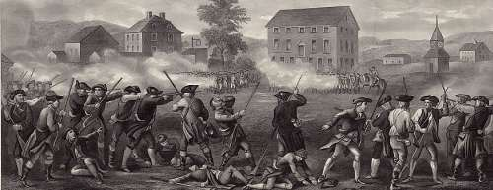
Lexington and Concord

Proclamation of 1763
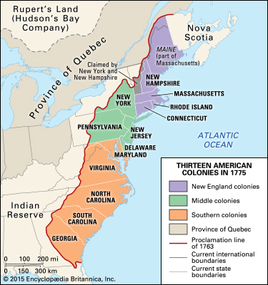

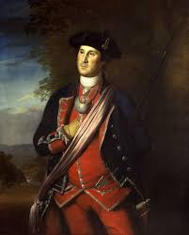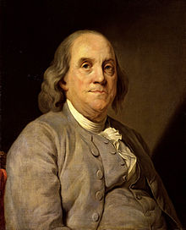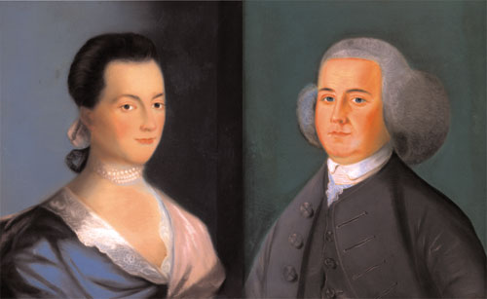
George Washington Benjamin Franklin Abigail Adams John Adams

Crispus Attucks Partrick Henry Mercy Otis Warren Samuel Adams

