"A soldier would usually occupy a front line trench for only a week at a time.
"There is an important thing to understand about trench warfare and what it was like to be in the trenches. It was not the same people in the same trench all through the war. The army realized that even in quiet periods, being in the front line was a terribly wearing experience.
"At any moment, if you put your head above the parapet, a sniper might get you; at any moment, a trench mortar or shell might land among you, killing and maiming. Consequently, people there are living in a state of great anxiety, which if continued for long, would wear them down; and they would wear down pretty rapidly to the point where they can't be used again.
"To avoid this, the army was constantly recycling people, having them in the front line a week at a time, then moving them to reserve trenches, then moving them out of the lines altogether (giving them time to recuperate), and then bringing them back again."
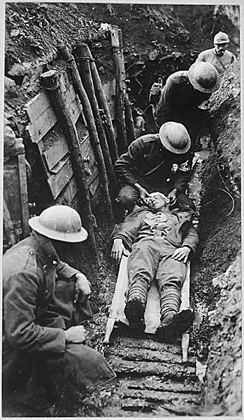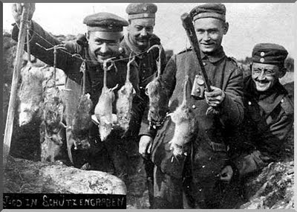

http://www.pbs.org/greatwar/historian/hist_wilson_02_trench.html
WWI: Trenches What They Were Really Like by Paul Fussell
"The first thing was it smelled bad.
"It smelled bad because there were open latrines everywhere. There were bodies rotting everywhere. Nothing could be done about them. You could throw a shovel full of quick lime on them to take some of the smell away, but the odor of the trenches was appalling.
"It's hard to imagine people living for years in the middle of that smell. That's what they had to endure. For the most part there were no bunks, no places to lie down when you weren't on duty; so you lay in the mud, in a hole cut in the side of the trench, or in a dugout if you were an officer or an NCO.

"The best time for attacking is in the early morning; partly because you have the advantage of darkness in forming the troops up.
"You also have the advantage of a full day in which you can prosecute the development of the attack before it gets dark again. Both the Germans and the British had morning stand-to, which is short for stand-to-arms.
"In the darkness as dawn was just about to open up, they would each stand on their firing steps in the trenches, which puts you about this high above the trench. You stood there with your loaded rifle waiting for an attack from the Germans. The Germans did the same thing.
"When it was fully light, and it was clear that no attack was going to happen that morning, you stood down and had breakfast. Eating it on the firing trench, which was like a building bench in the trench you were occupying.

"Then there's nothing to do all day, except listen to the bangs as the shells went off everywhere.
"The object of each side was to try to put mortar shells into the enemy trench and blow it up, or kill the people in it. So there's constant noise and bombardment all day long. Now one couldn't stay forever in the trenches. You stayed usually about a week. Then you were rotated back with another unit, and a fresh unit came up for its week of trench duty.

"There were rats the size of cats.
"Both the Germans and the British were troubled with rats. The rats ate corpses, then they came in and snuggled next to you while you were sleeping. And they ate your own food, and they were filthy creatures. They also carried disease – bubonic plague primarily.
"Many people think that the great flu epidemic of 1919, which affected the United States, had something to do with bubonic plague, which was being carried by these trench rats. Actually, more American troops died of flu than of bullets and shell fragments in the war.

"Sky study becomes one of your few amusements.
"You never see your enemy and the only thing you can see is the sky up above. You look at the sky constantly from the opening of the trench, because you can't look out to the side. All of your view is vertical. You consequently get very interested in birds for the first time, because those are the only animated things you can see, except for rats and lice, or other human beings.

"You never see the enemy except when he's attacking, or you're attacking and you get close to him. So it's a curious, almost studious isolation that the troops are in. They're isolated from the setting and they're isolated, of course, from home, from normal pursuits, and so on. You could read in the trenches sometimes, but it was pretty hard to do with all the explosions going off all the time."

http://www.pbs.org/greatwar/historian/hist_fussell_03_trenches.html

