The Triangular Trade 6 points Name ____________________________

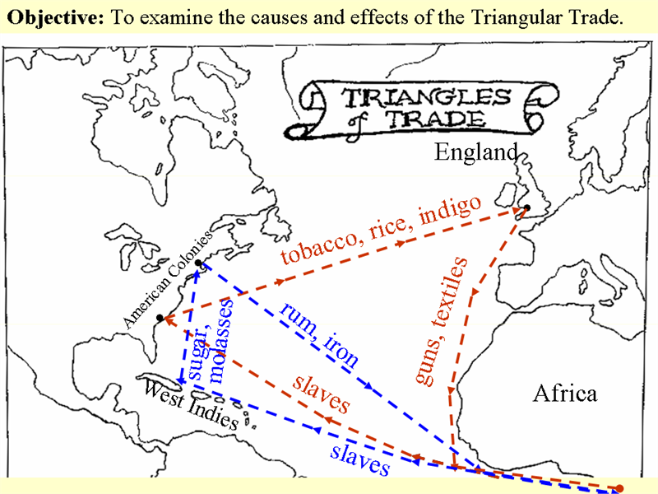

Introduction: The origins of the African Slave Trade can be traced back to the Age of Exploration in the 15th Century. Europeans had become quite addicted to the luxuries of exotic spices, silks and porcelain that could only be found in Asia. Unfortunately for them, Muslim traders had a complete monopoly over the trade routes to the Far East. Unsuccessful in the attempt to break that monopoly, they started to explore water routes that would enable them to bypass the Muslims. The Portuguese took the lead in that exploration and sent voyages down the west coast of Africa in hopes of finding a new route to the source of traded goods. On those voyages they found a new type of good- human beings.

Why did the Slave Trade Begin?
Mercantilism in Europe drove European countries to explore the world, establish an empire of colonies, and bring back raw and produced goods to export from the mother country to be used or exported. As European empires expanded to the New World, however, they lacked one major resource - a work force. In most cases the indigenous (native) peoples had proved unreliable (most of them were dying from diseases brought over from Europe), and Europeans were unsuited to the climate and suffered under tropical diseases. Africans, on the other hand, were excellent workers: they often had experience of agriculture and keeping cattle, they were used to a tropical climate, resistant to tropical diseases, and they could be "worked very hard" on plantations or in mines.

What was the Triangular Trade?
All three stages of the Triangular Trade proved lucrative for merchants. The first stage of the Triangular Trade involved taking manufactured goods from Europe to Africa: cloth, spirit, tobacco, beads, cowrie shells, metal goods, and guns. The guns were used to help expand empires and obtain more slaves (until they were finally used against European colonizers). These goods were exchanged for African slaves. The second stage of the Triangular Trade, The Middle Passage, involved shipping the slaves to the Americas. The third, and final, stage of the Triangular Trade involved the return to Europe with the produce from the slave-labor plantations: cotton, sugar, tobacco, molasses and rum.

Arrival in the Americas
As a result of the slave trade, five times as many Africans arrived in the Americas than Europeans. Slaves were needed on plantations and for mines and the majority was shipped to Brazil, the Caribbean, and the Spanish Empire. Less than5% traveled to the Northern American States formally held by the British.

1. Describe all 3 sides of the Triangular Trade. 6 pts.

