Name _________________________________
U.S. Map for Topic 13 56 points Date ________________________ hour _____

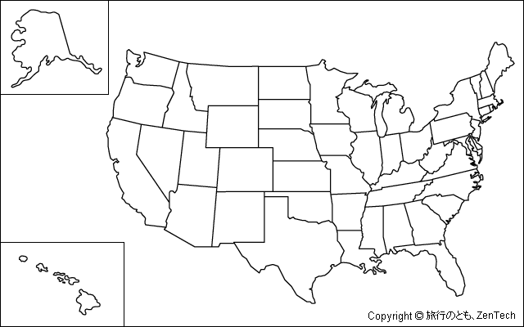
Use the maps in Topic 13 on pp. 701, 742, and 1042. Label all 50 states, Label Canada and Mexico, Label the Atlantic and Pacific Oceans, you DO NOT have to color 2 points for neatness

