Name ______________________
Vietnam War Map Date _______________ Hour ___
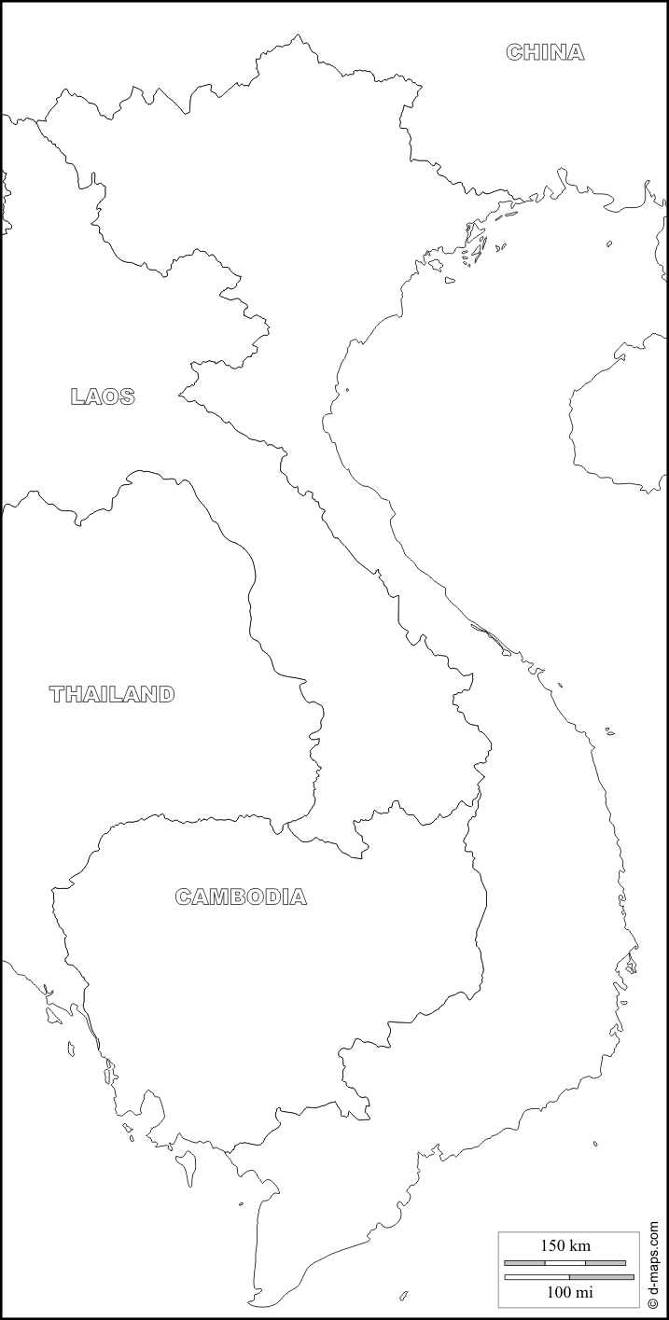
20 points possible

Use the map on p. 843.

Label the following:
Water-
Gulf of Tonkin
South China Sea
Mekong River
Red River
Nations-
China
North Vietnam
South Vietnam
Thailand
Laos
Cambodia
Cities-
Dien Bien Phu
Hanoi
Haipong
Hue
Saigon
Danang

4 points for neatness

Gulf of
Thailand

