NAME ______________________________
Hour _______ Date ___________________
World Map: Follow directions, properly labeling and outlining all land shown. Use maps on 1044-1045 and in Topic 12. 30 points
Abbreviate but make sure it is legible, no sloppy outlining or labeling, 4 pts for neatness. You can also use world maps on the internet.
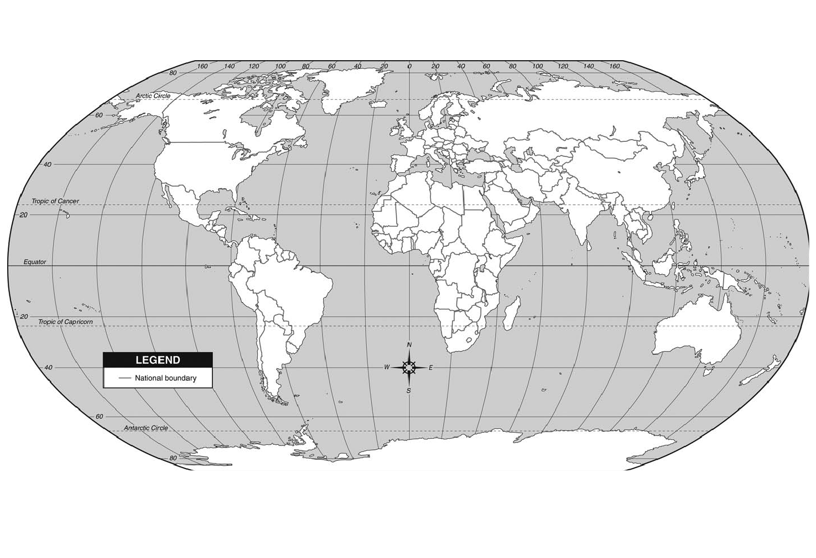
Label each continent and outline with a different color all parts of the continent. (14)

Label all 5 oceans. (5)

Label the following-(7)
Mexico
Japan
China
Philippines
Hawaii
Spain
Cuba

Be Neat (4)

30 Points Possible

