Name ___________________________________
World Map 40 points Date __________________________ Hour _____
Use pp. 874, 883, and 1044-1045
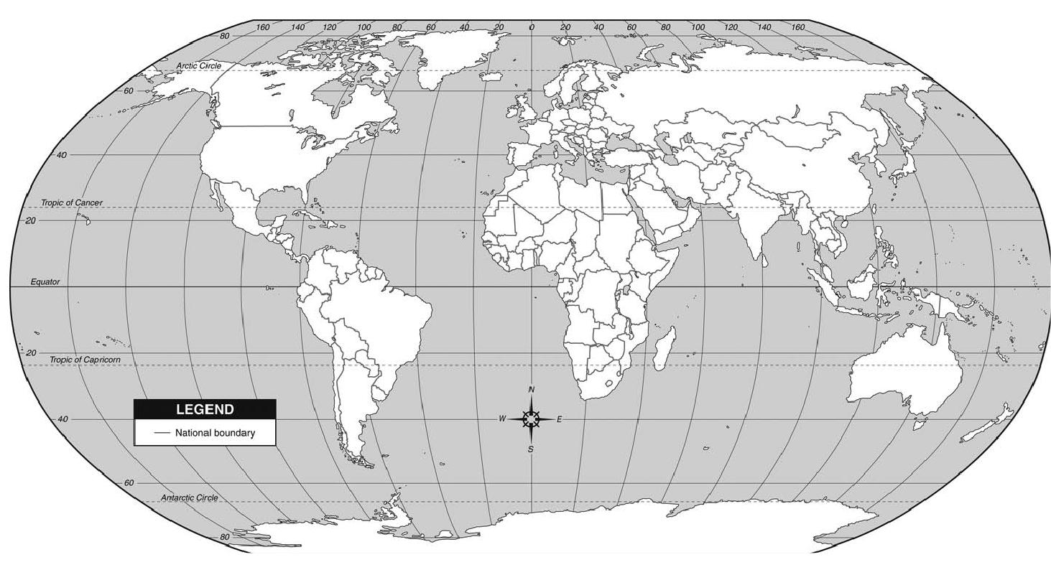
Label all 7 continents. Label the 5 oceans. Neatness = 4 points You map abbreviate.
Label the following countries:
Iran Afghanistan Pakistan China Japan the Philippines
Iraq Saudi Arabia Kuwait Russia Germany Serbia
Bosnia North & South Korea Nicaragua South Africa Israel Egypt
Somalia Northern Ireland Ireland Britain United States Cuba

